LINEAR AND MULTIVARIATE REGRESSION ALGORITHM

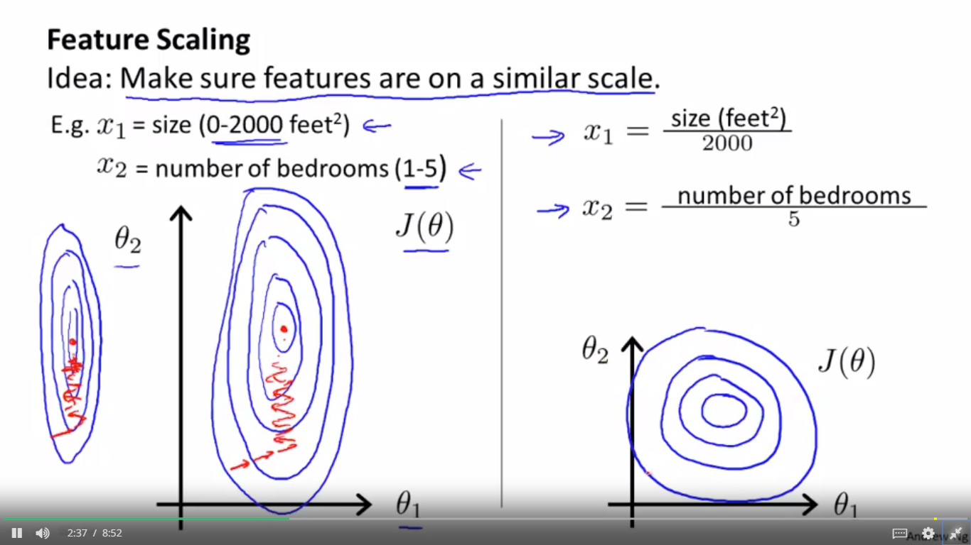

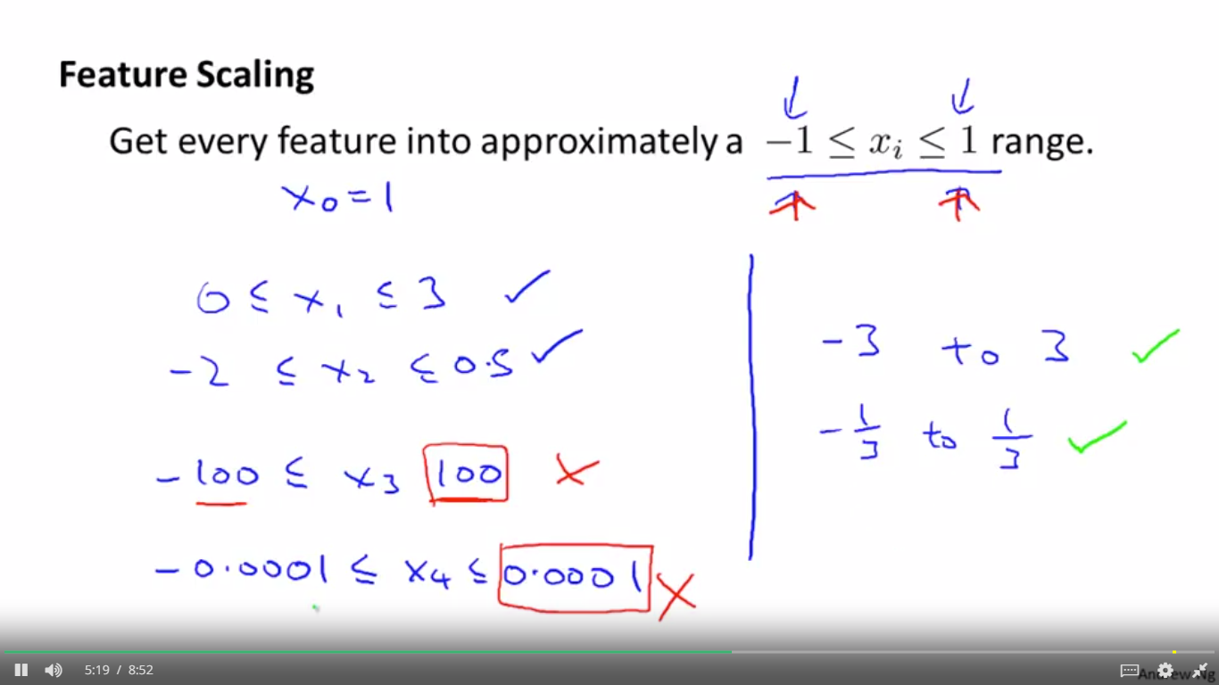

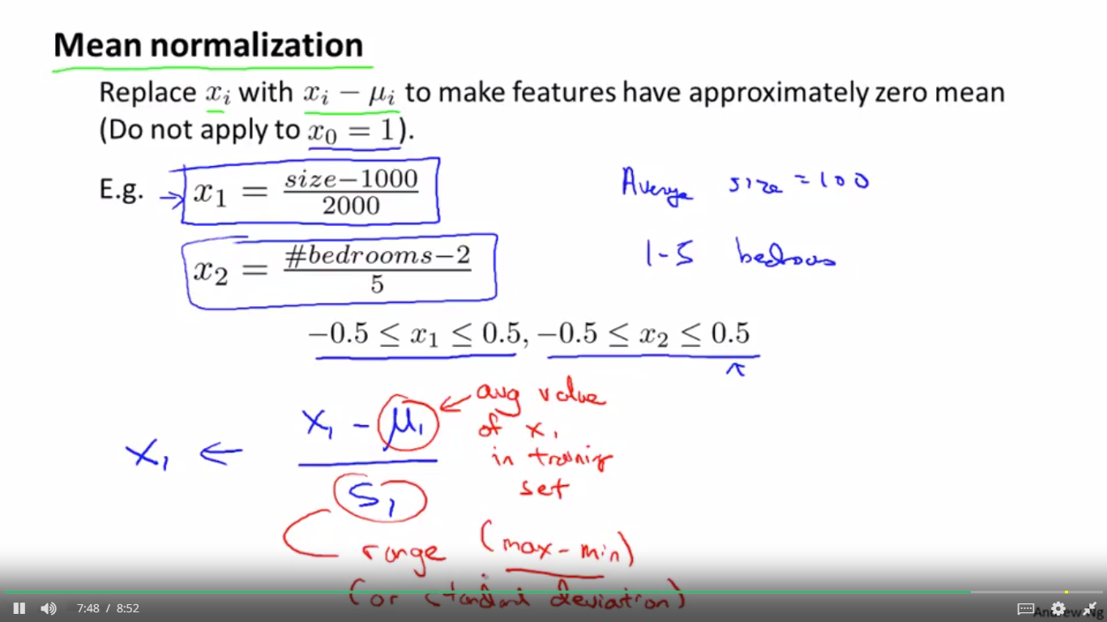

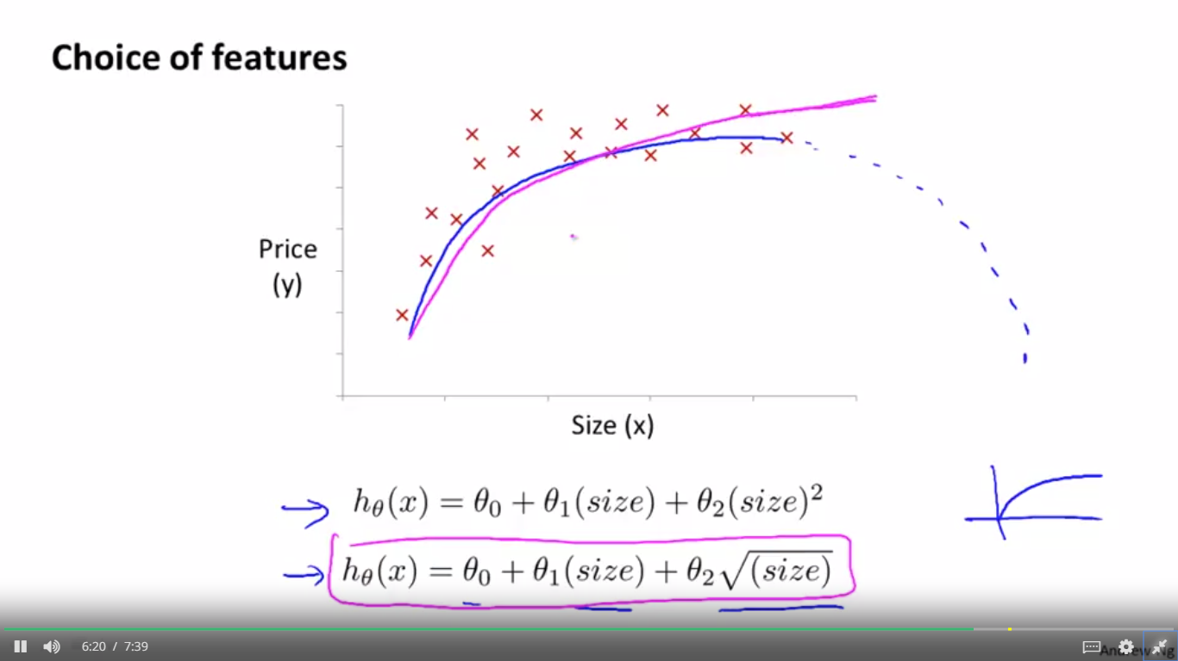

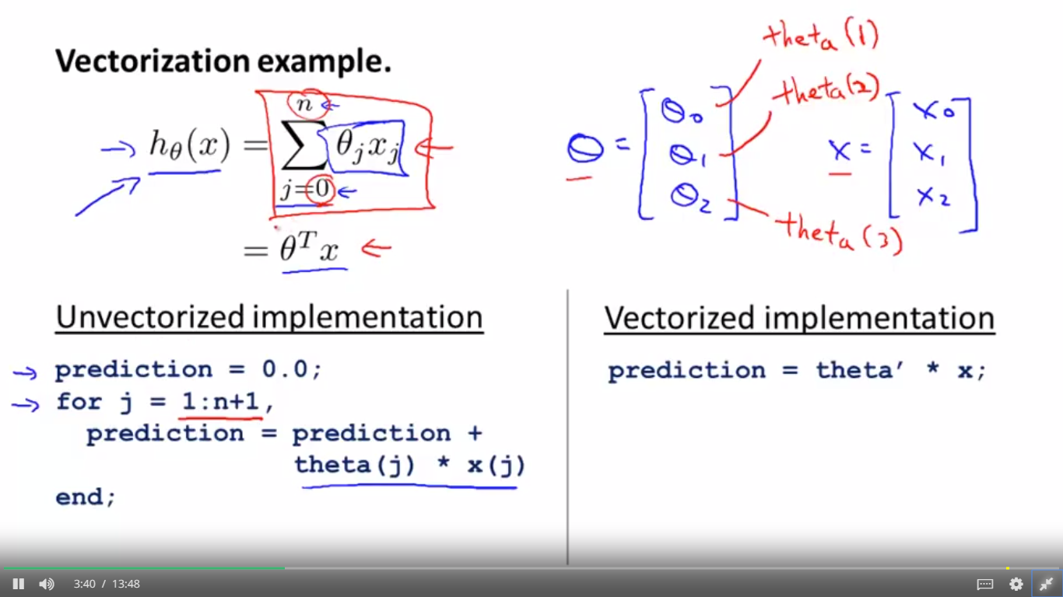

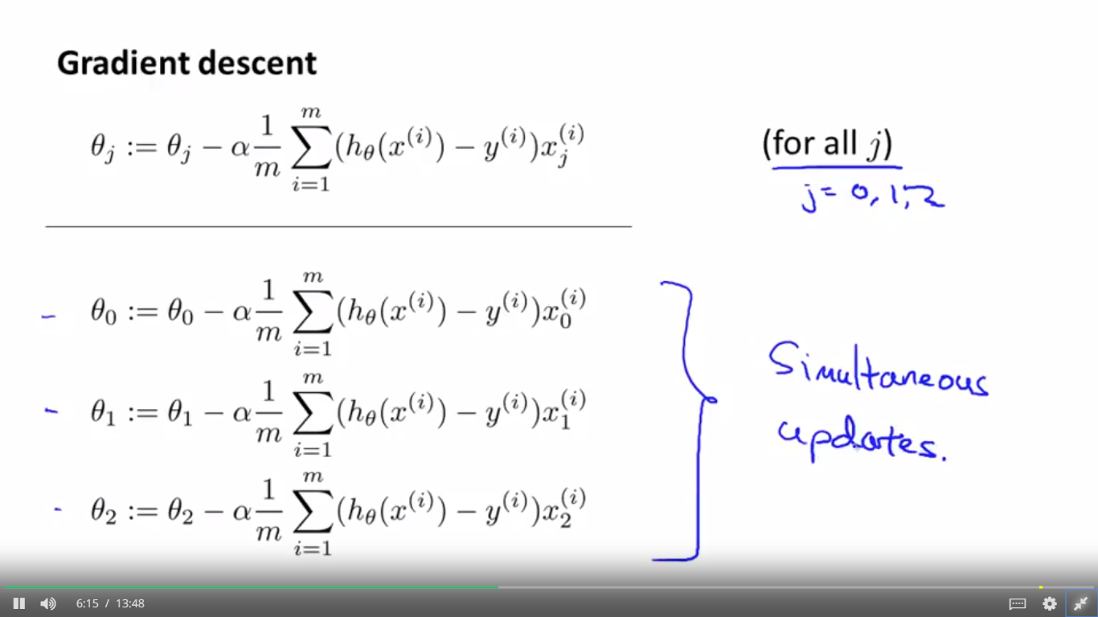

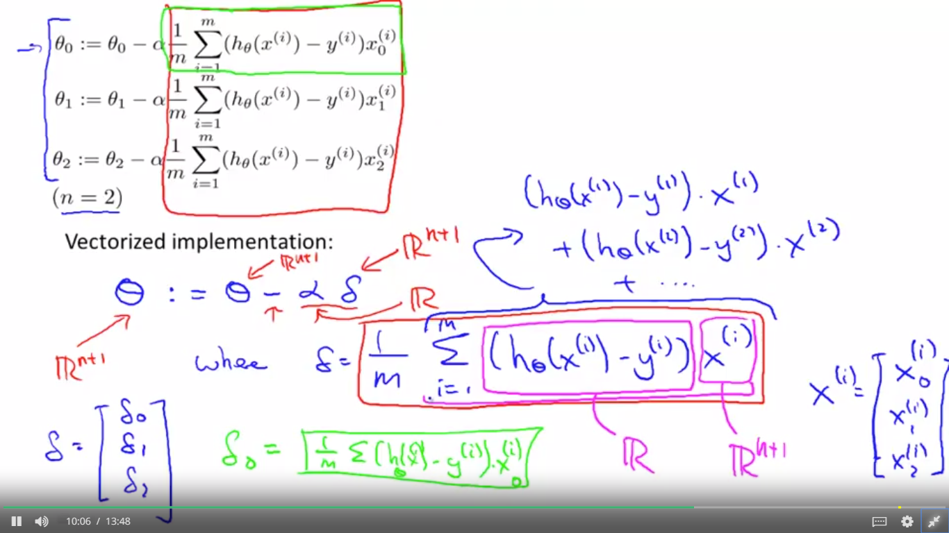

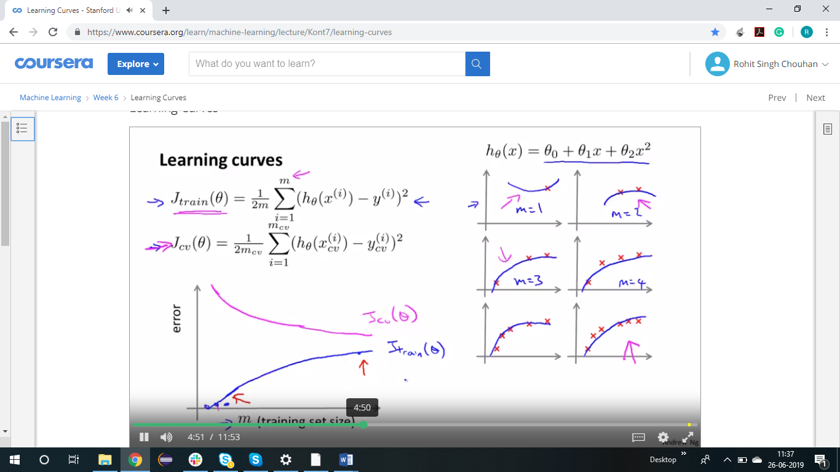

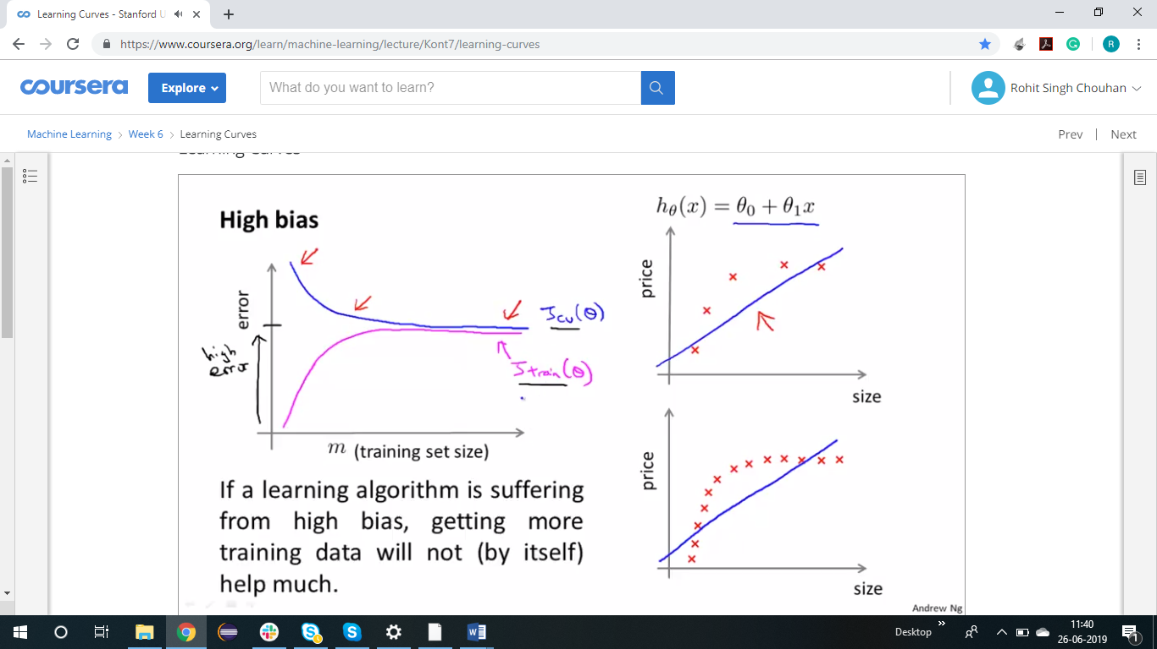

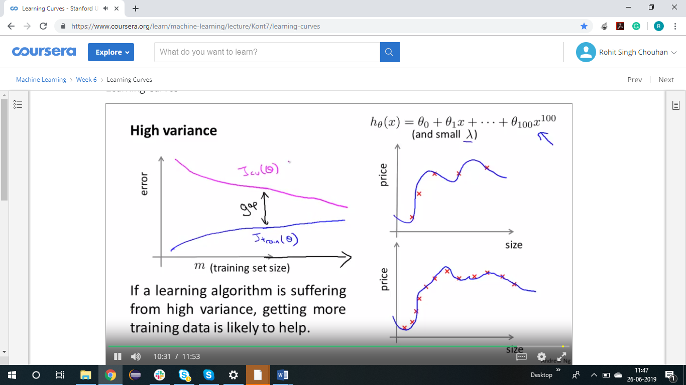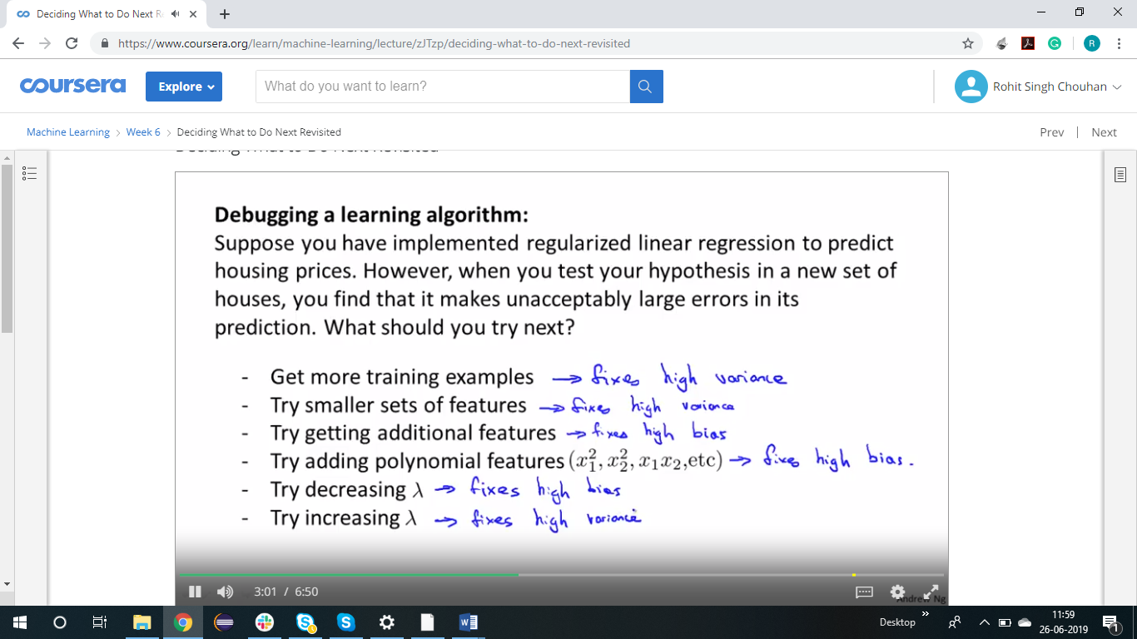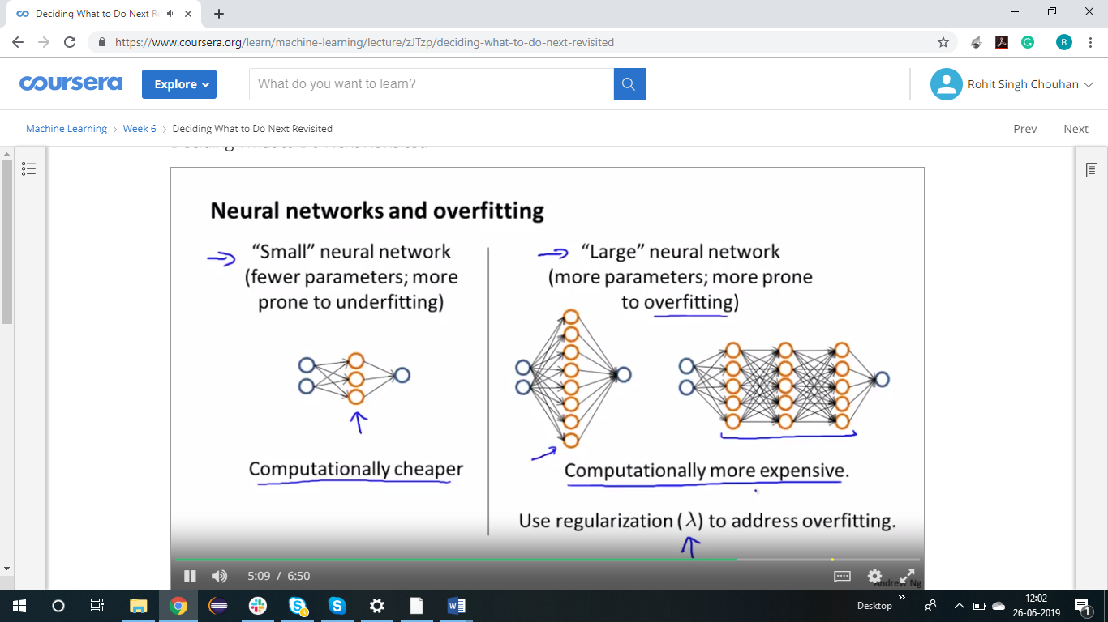

EVALUATING A LEARNING ALGORITHM

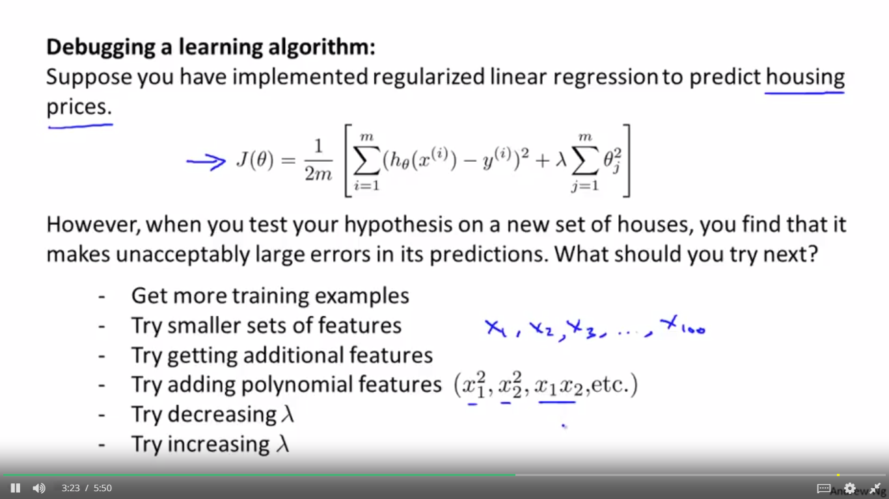

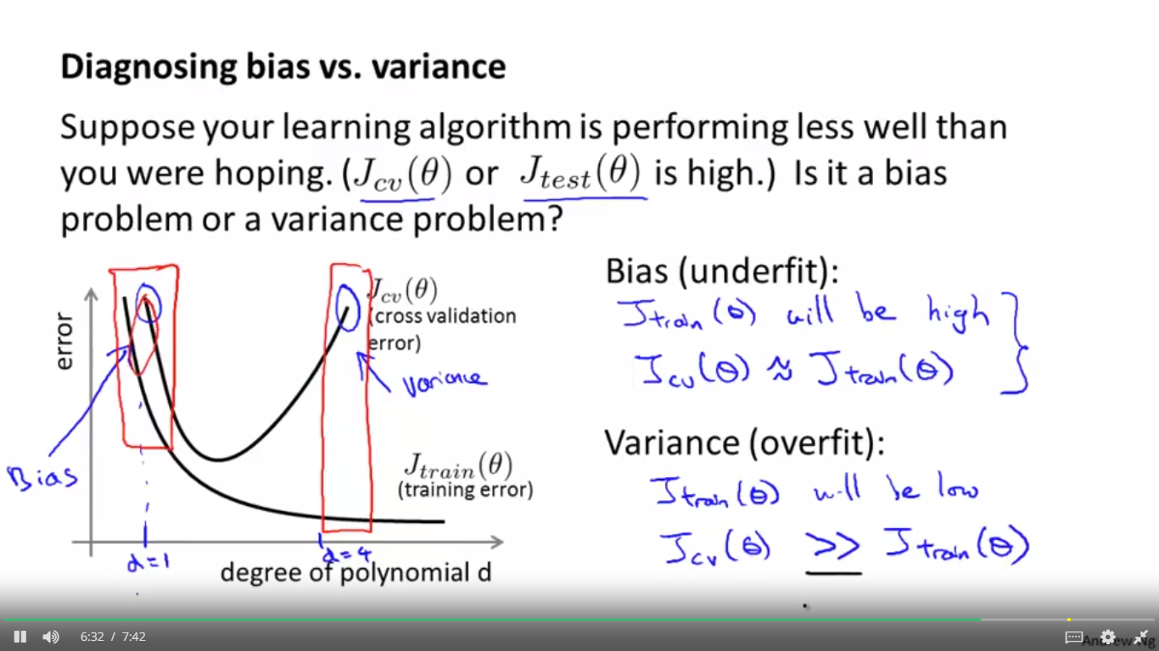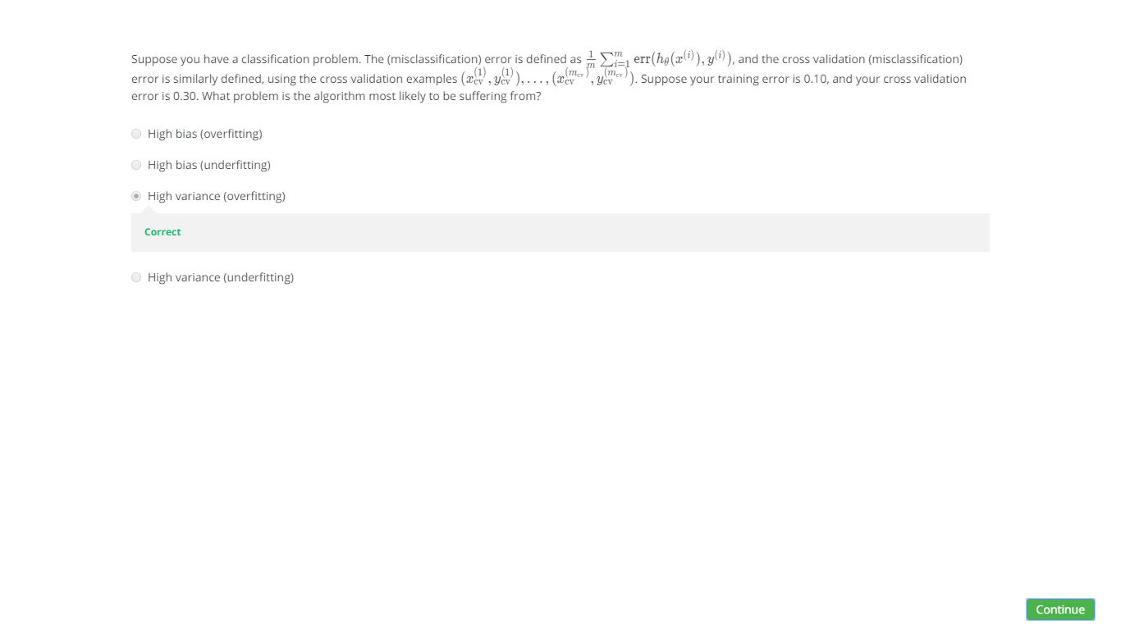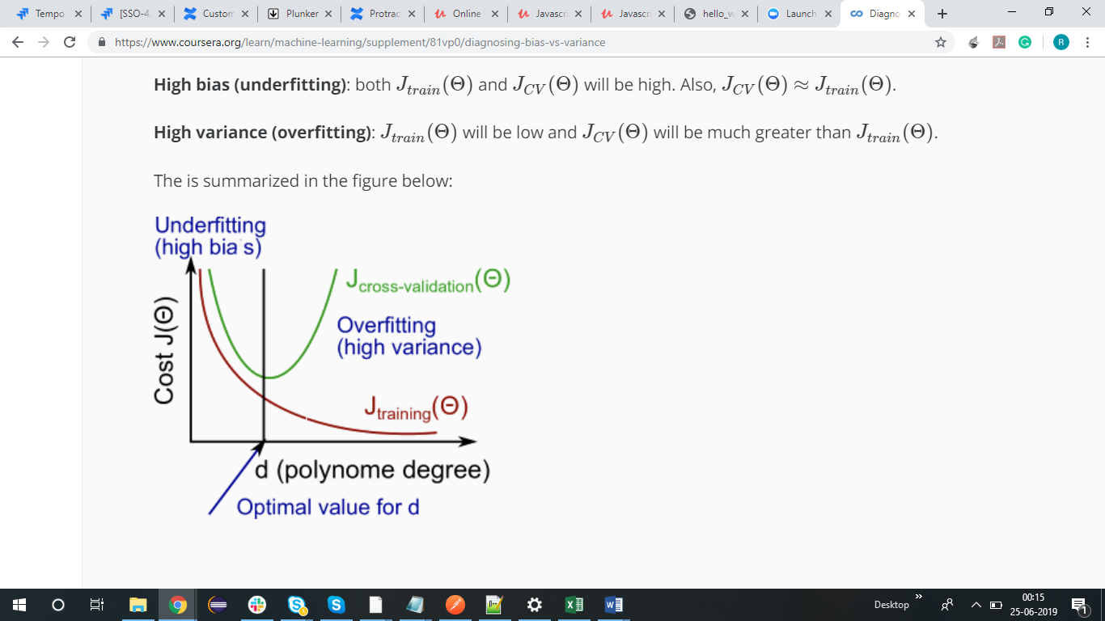

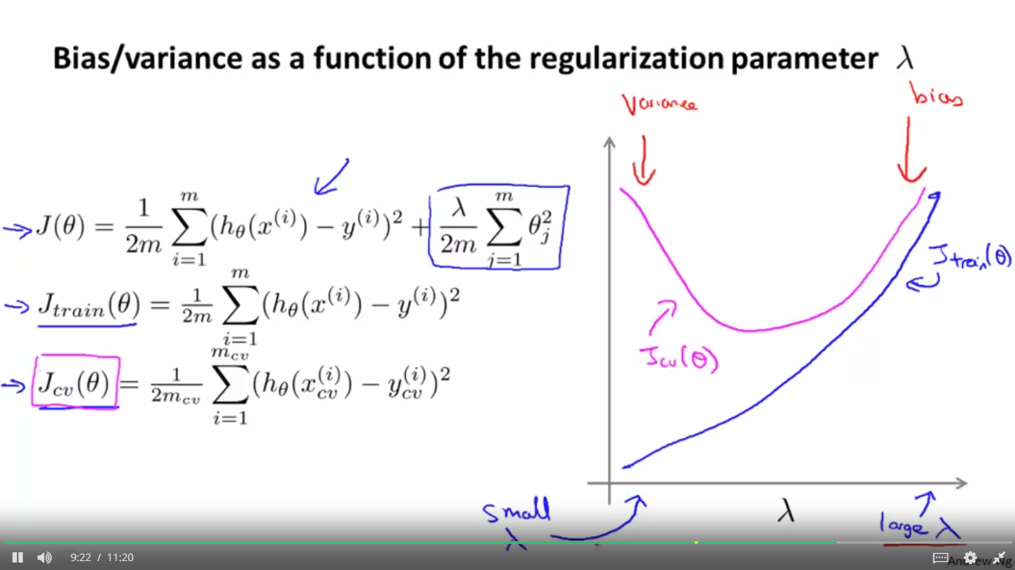

l43swbIeoU7q0gap

MACHINE LEARNING SYSTEM DESIGN

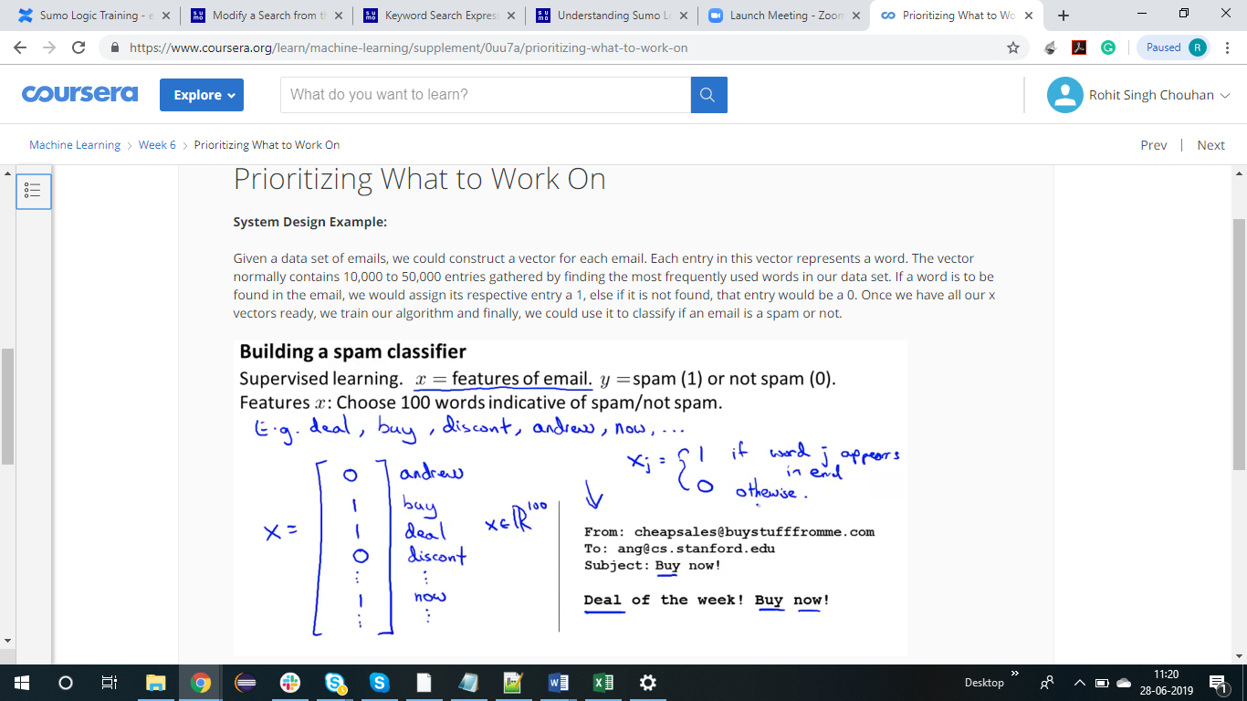

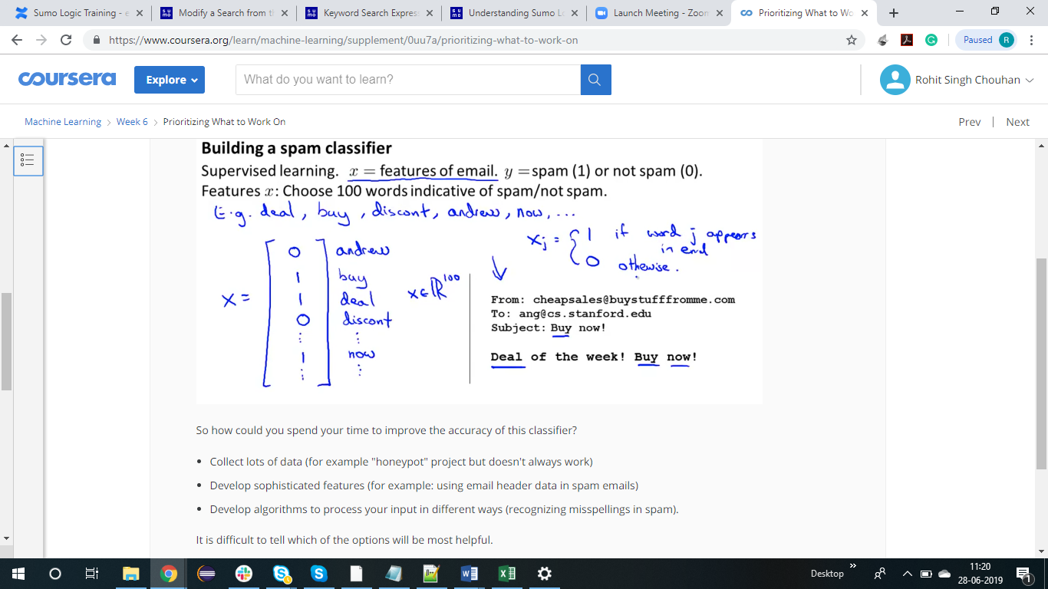

ERROR ANALYSIS

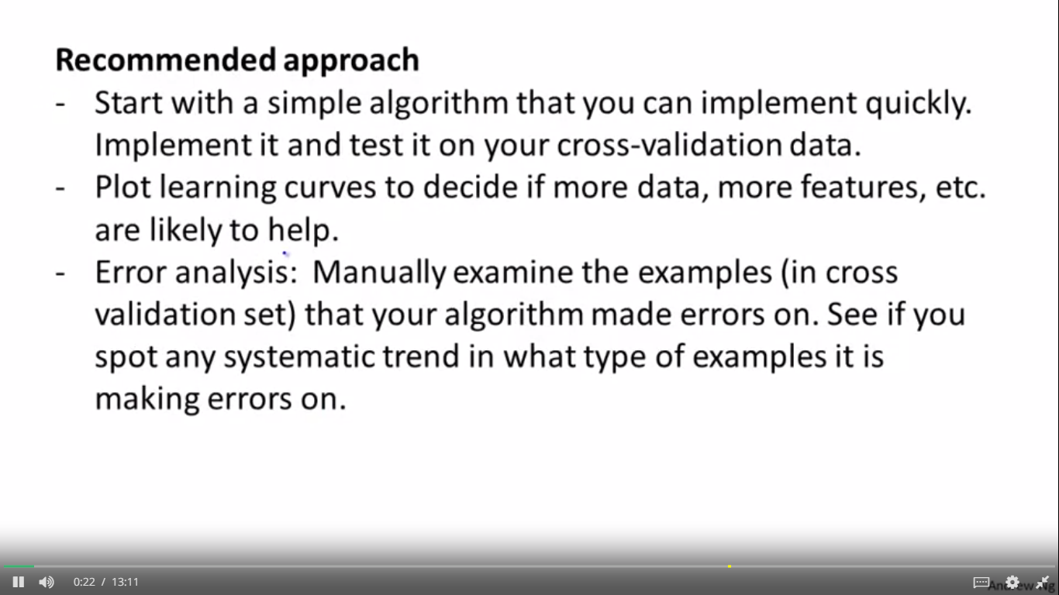

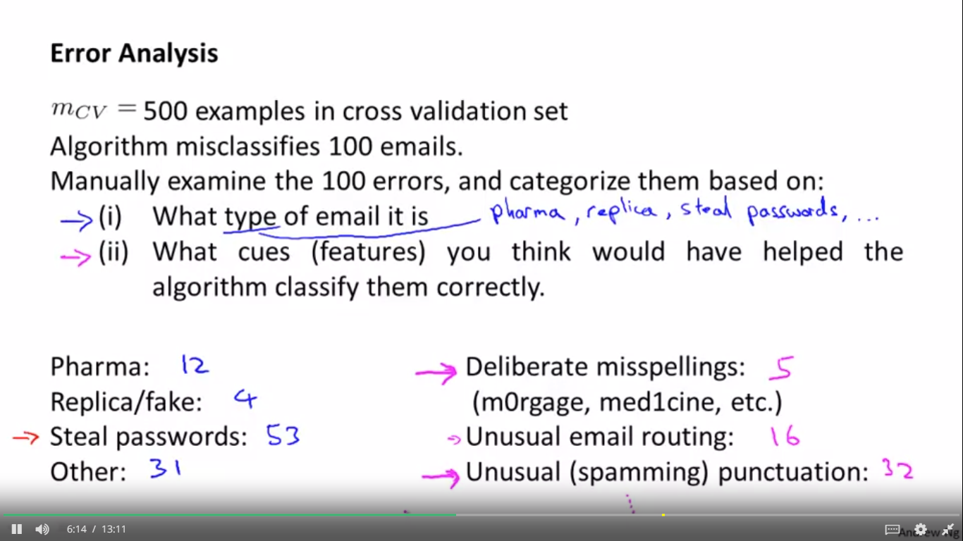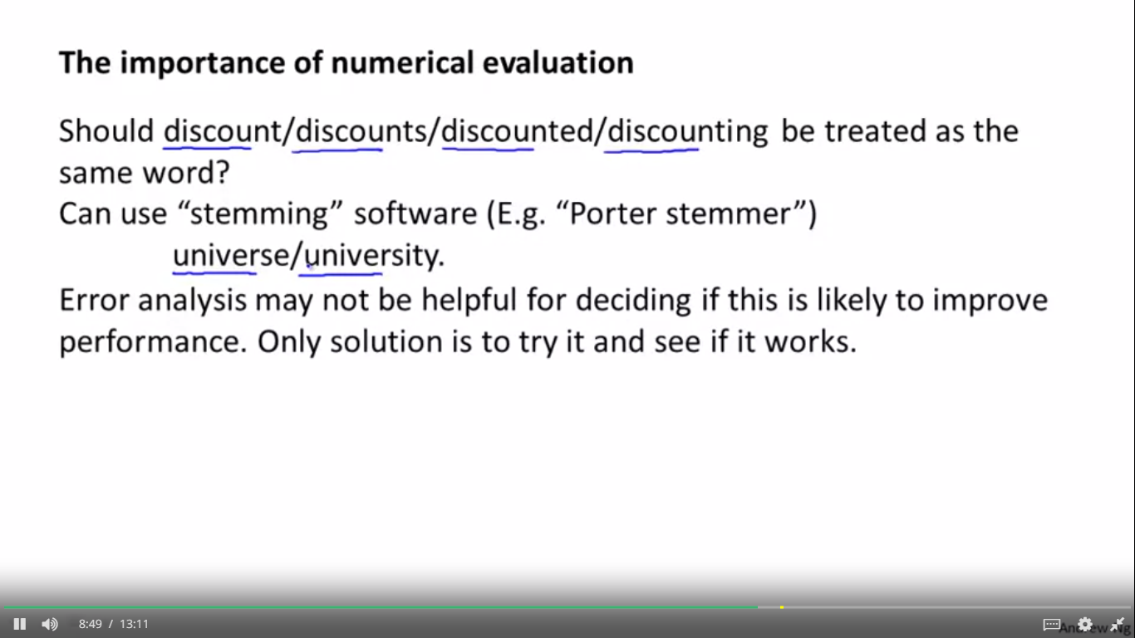

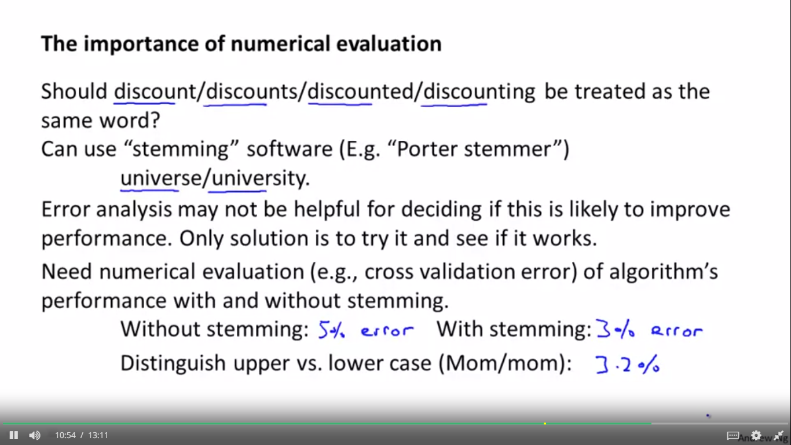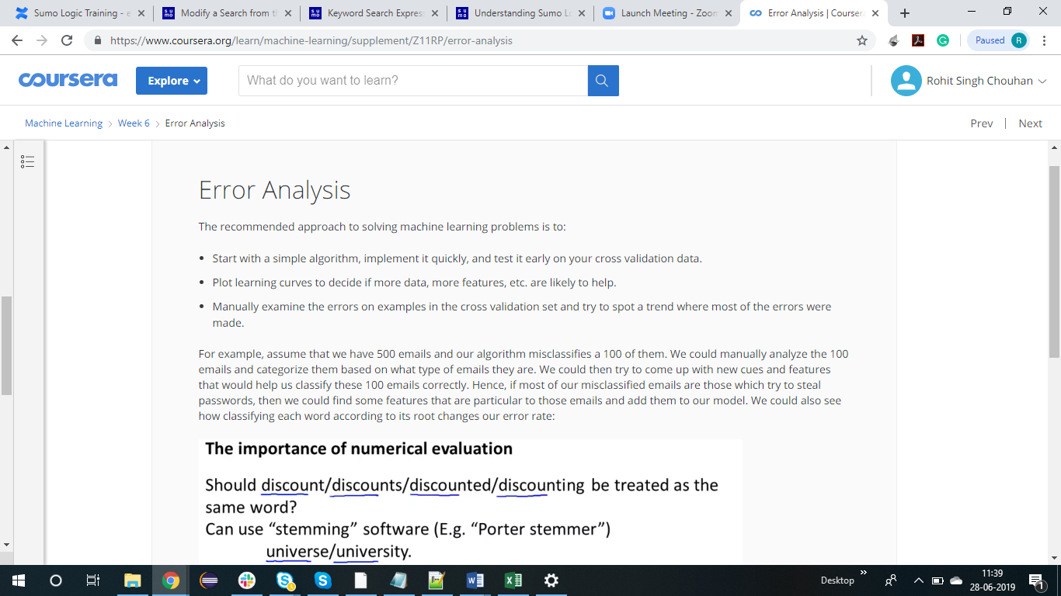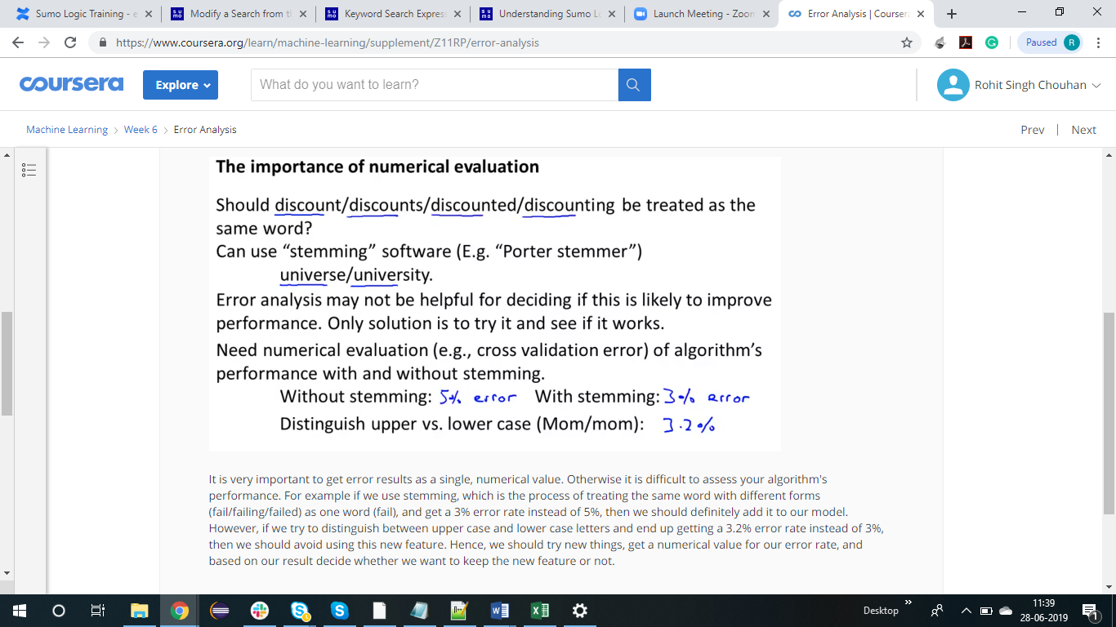

ERROR METRIC FOR SKEWED CLASSES

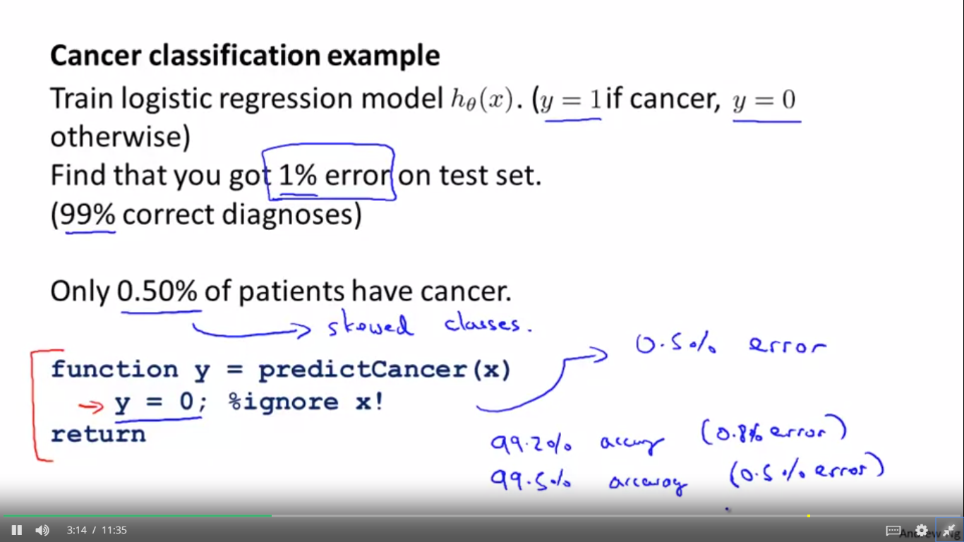

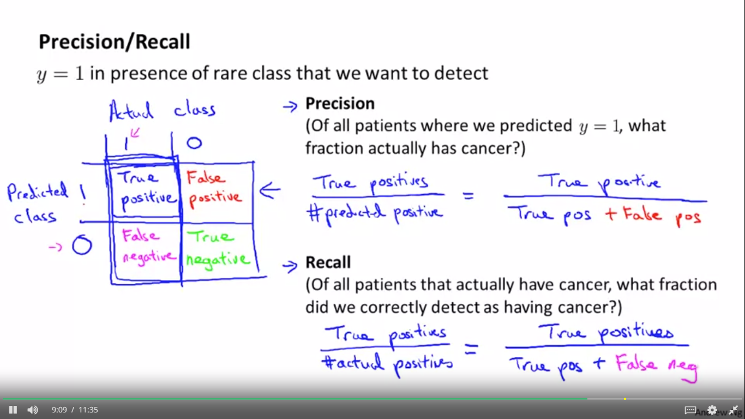

Positive and negative comes from predicted values i.e. what we are predicting

True comes when predicted is correct

False comes when predicted is incorrect

TRADING OFF PRECISION AND RECALL

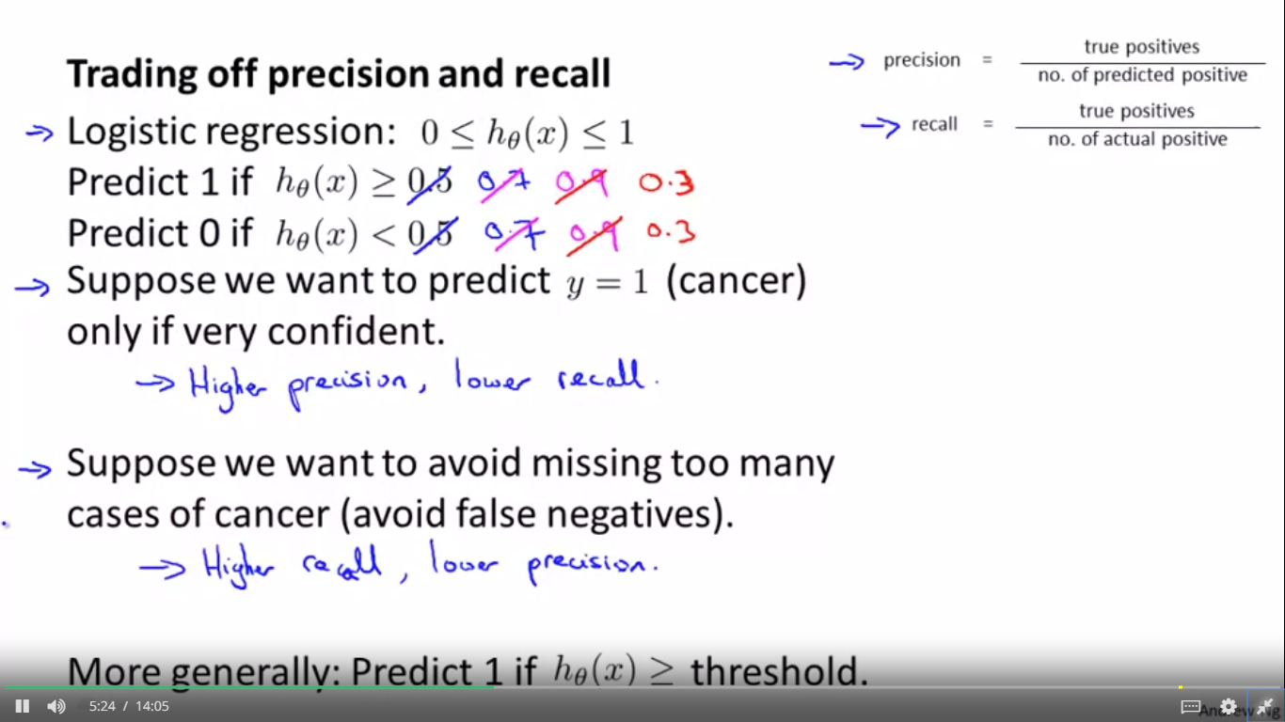

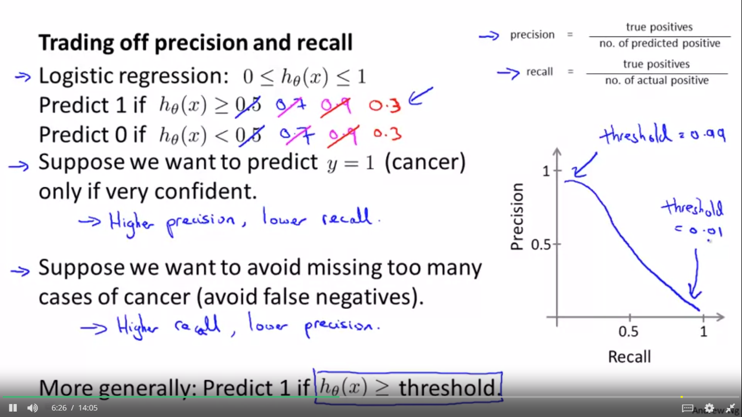

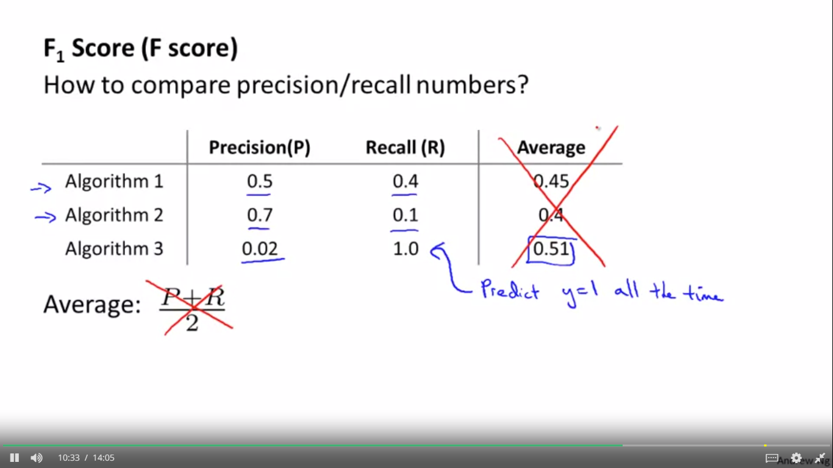

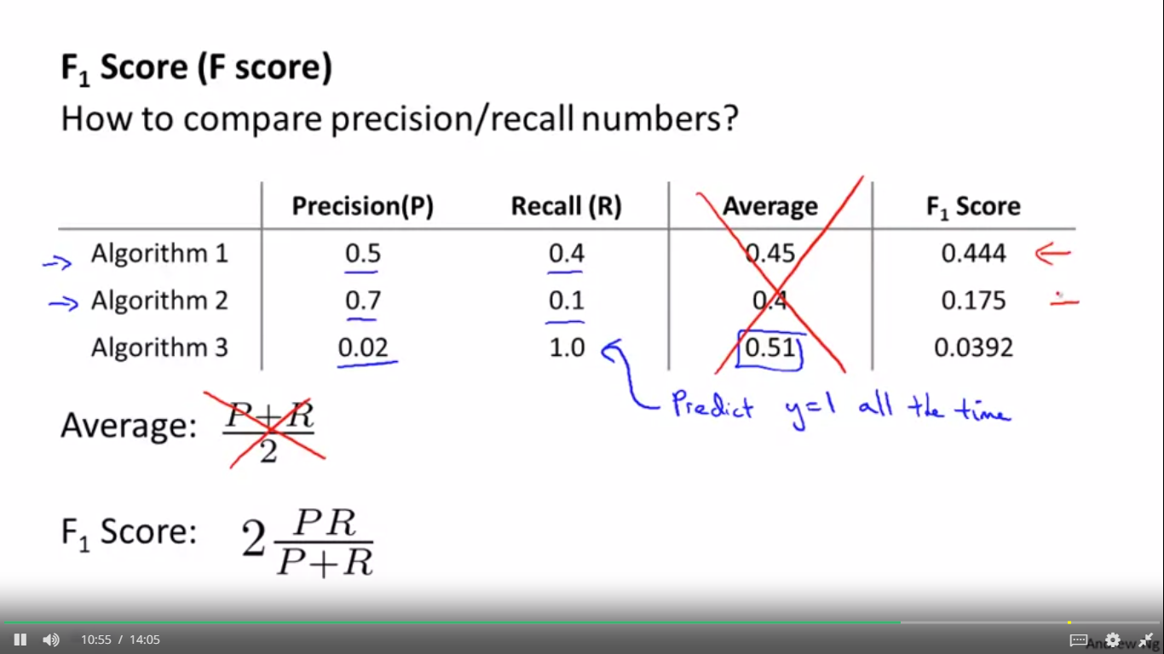

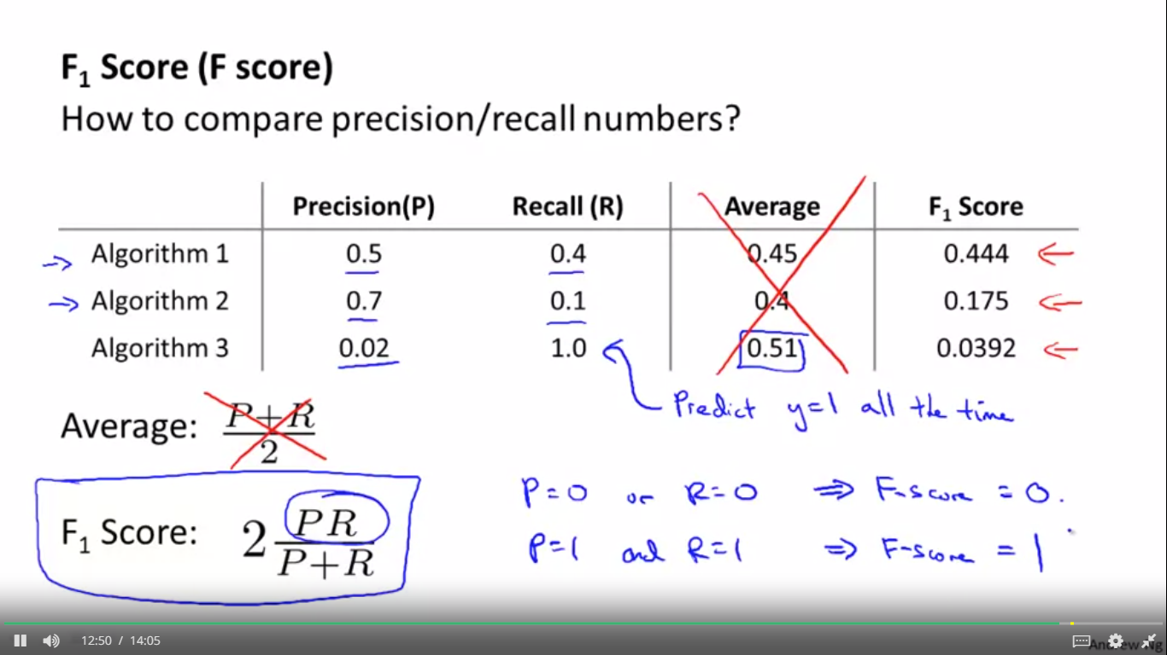

DATA FOR MACHINE LEARNING

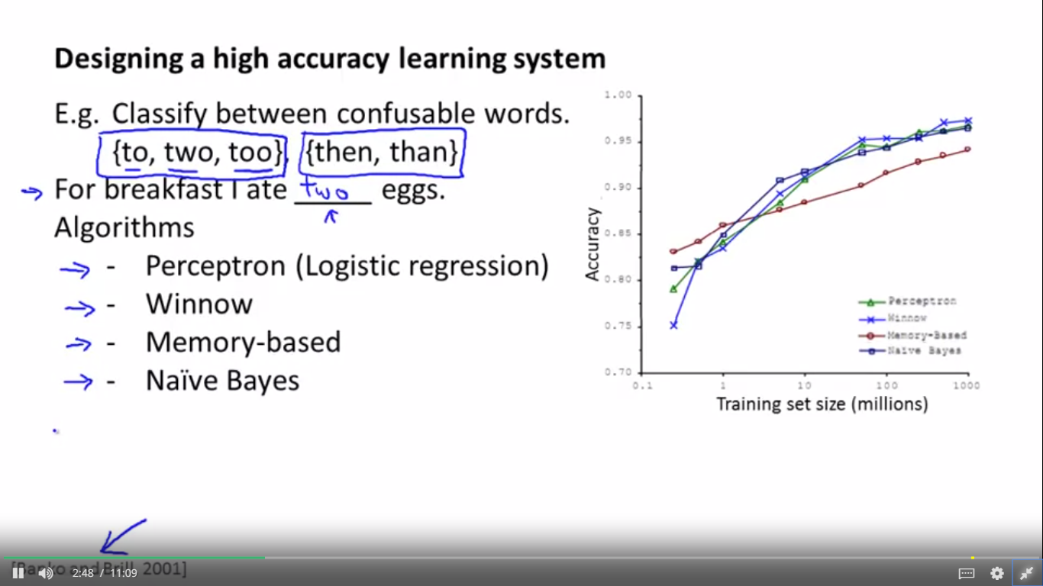 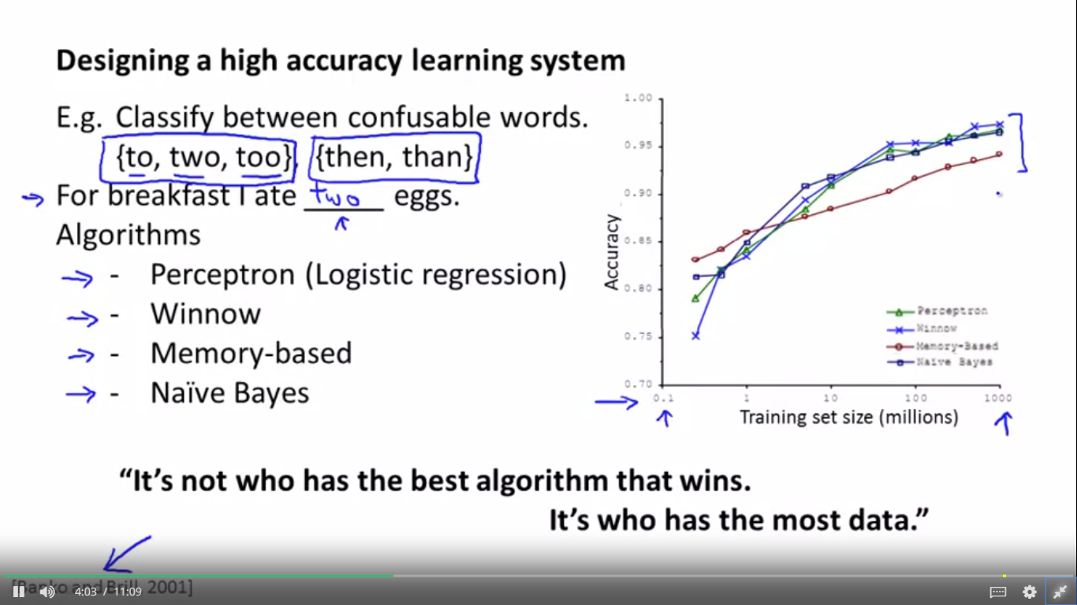

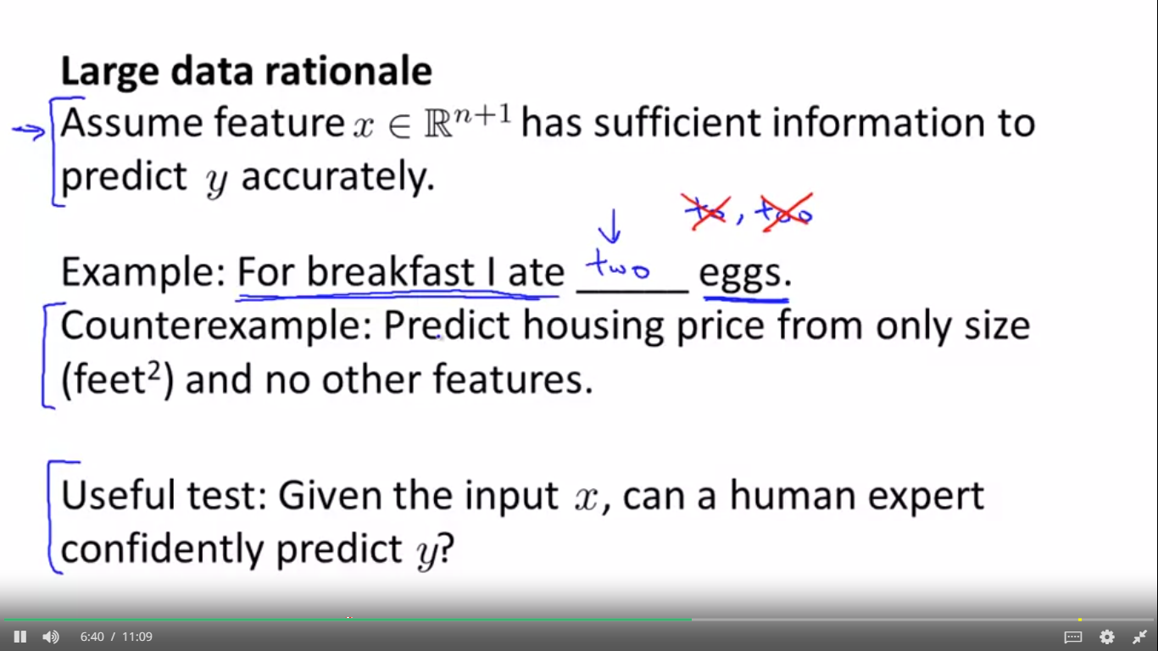

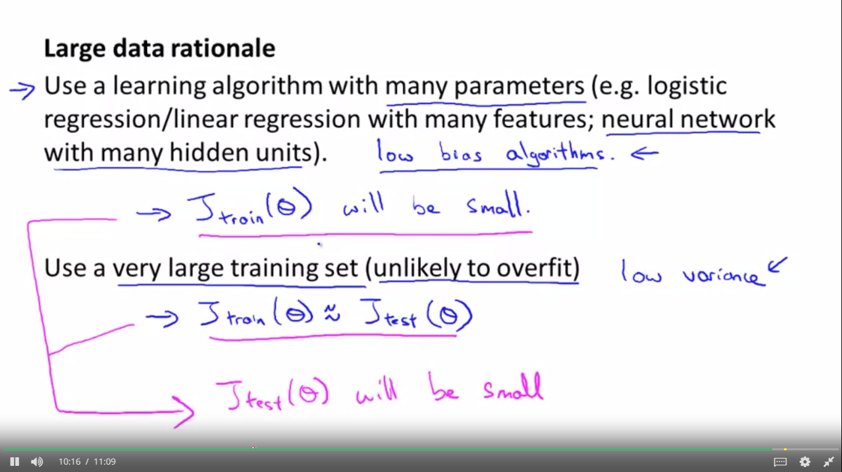

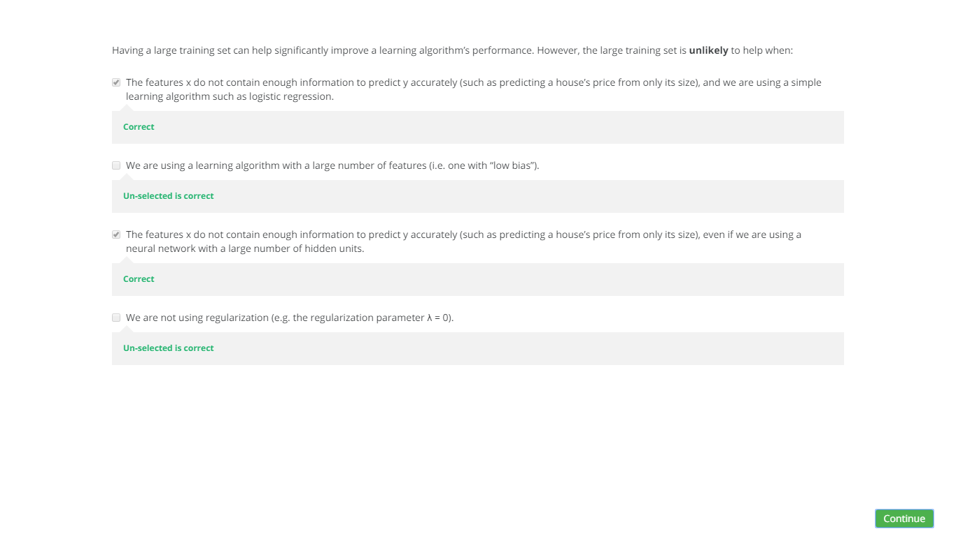

SUPPORT VECTOR MACHINE SVM

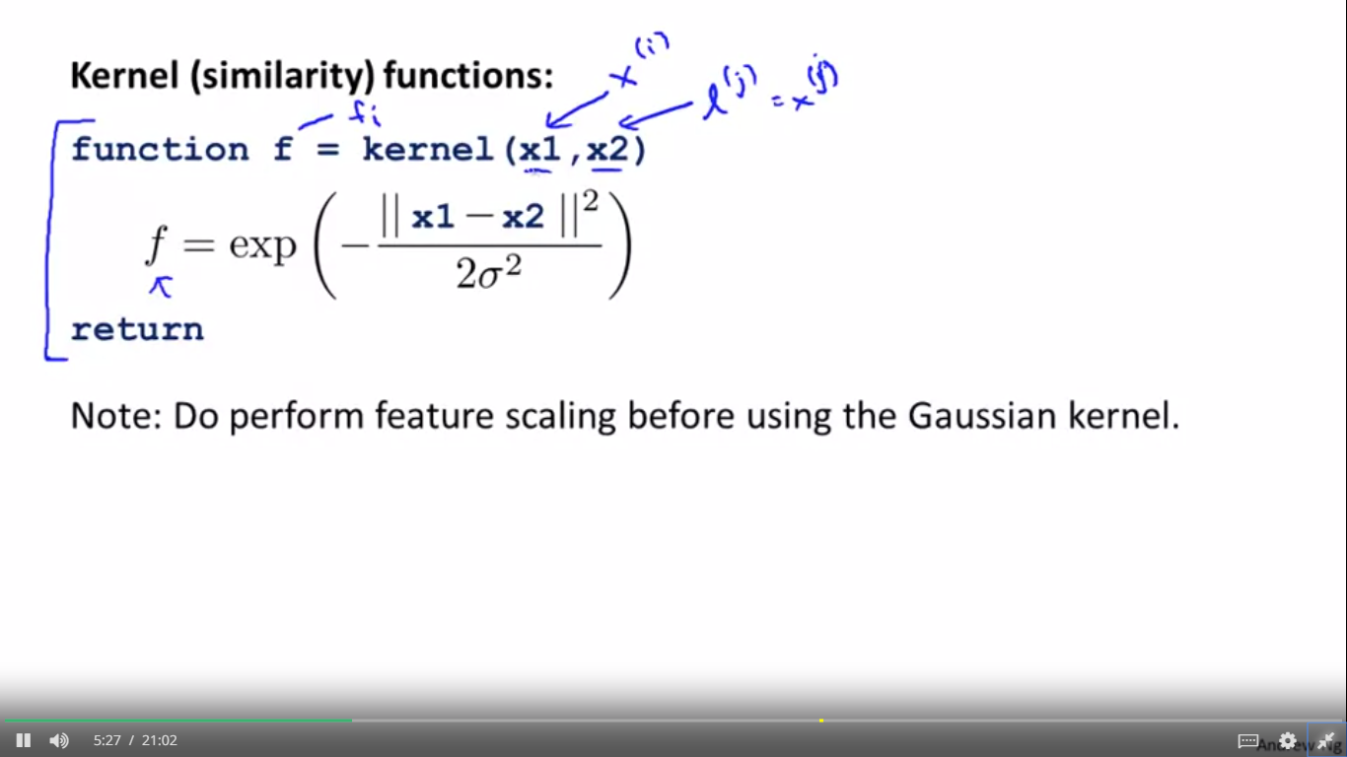

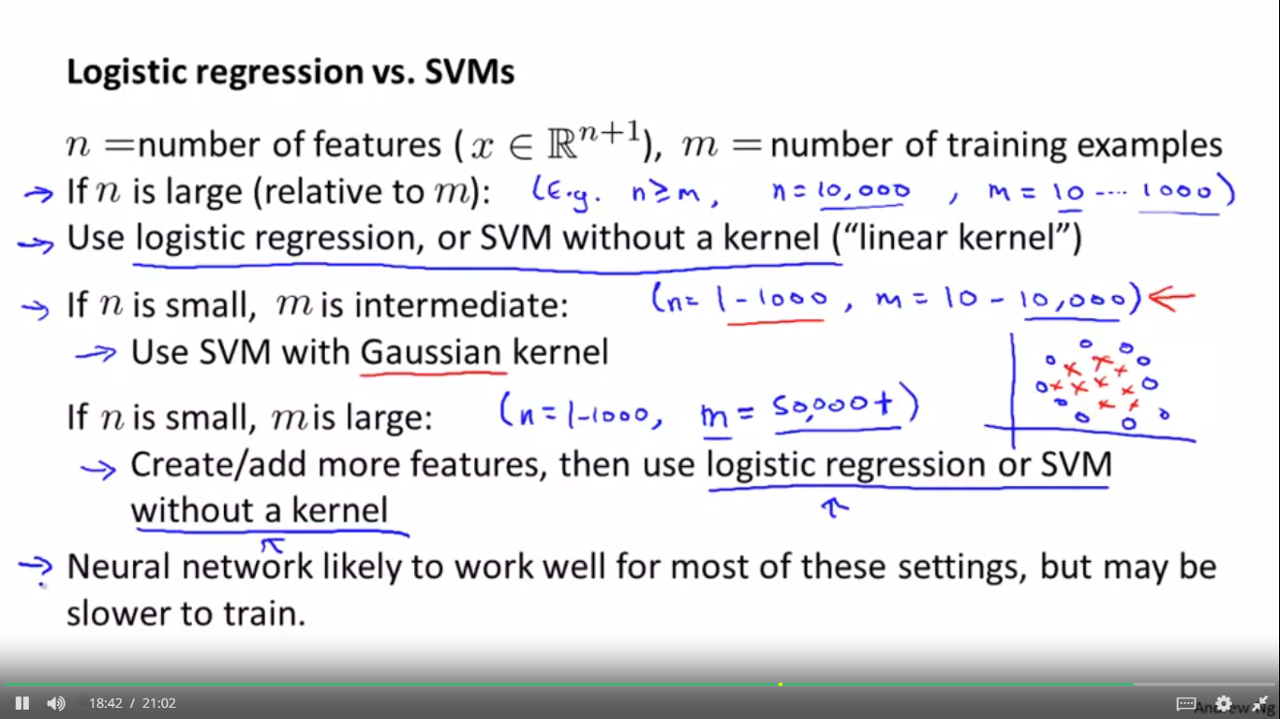

PCA

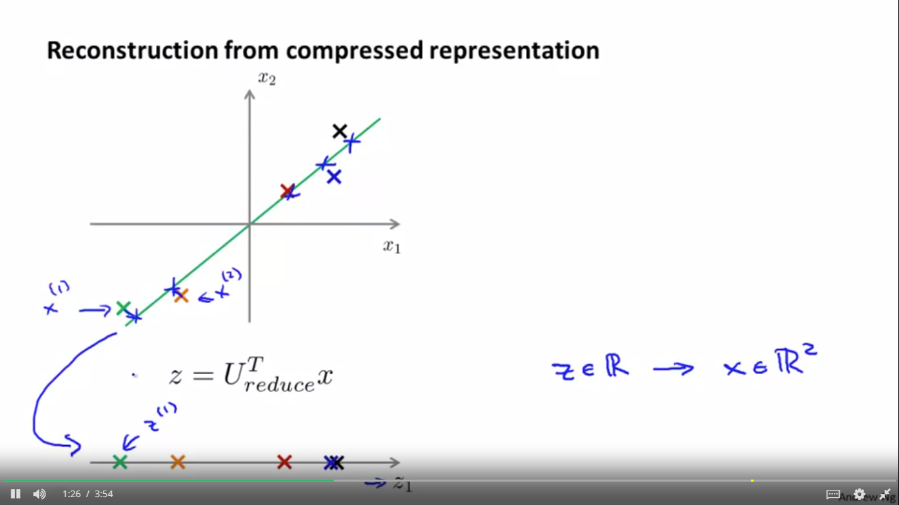

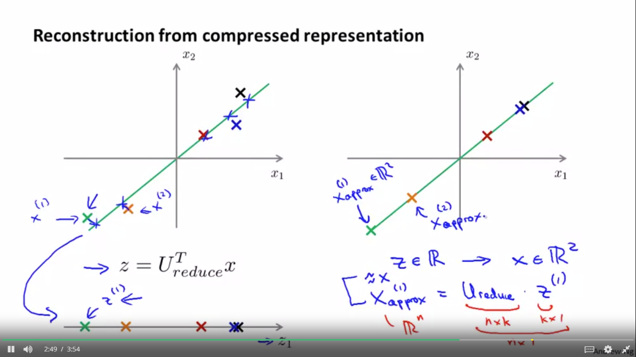

CHOOSING NUMBER OF PCA

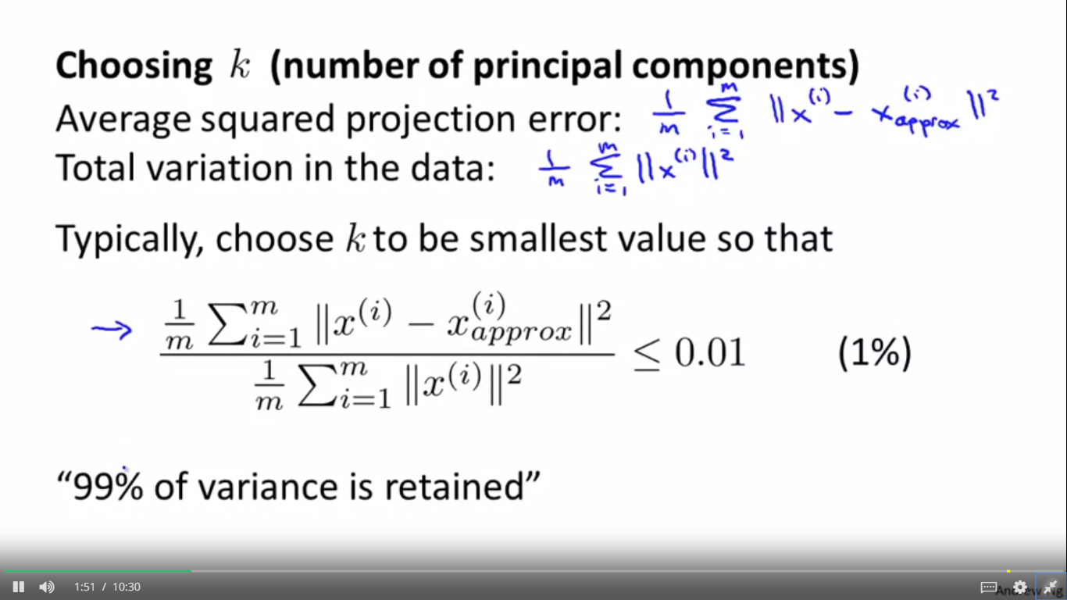

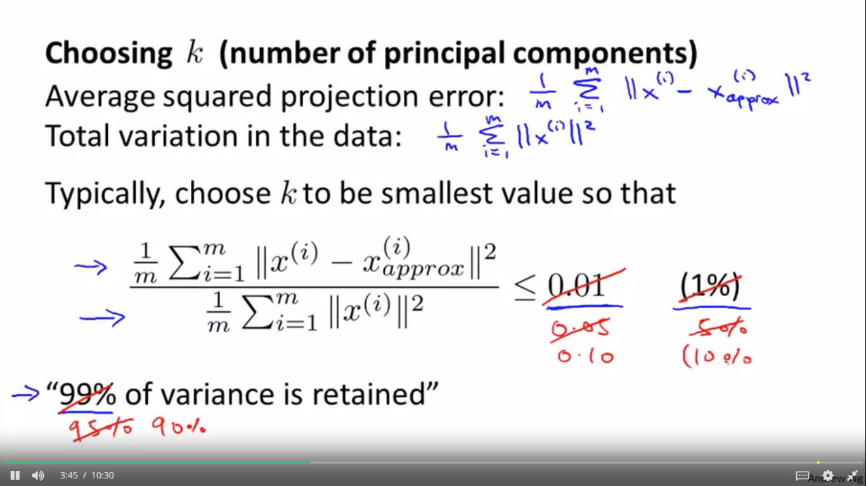

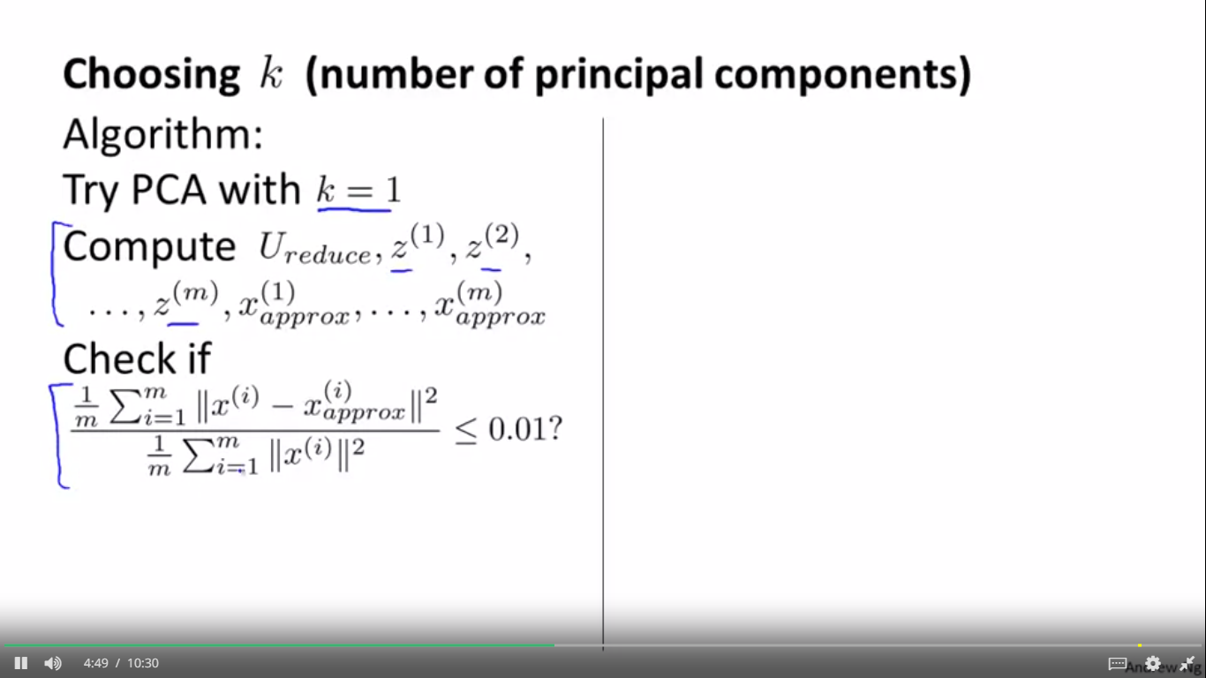

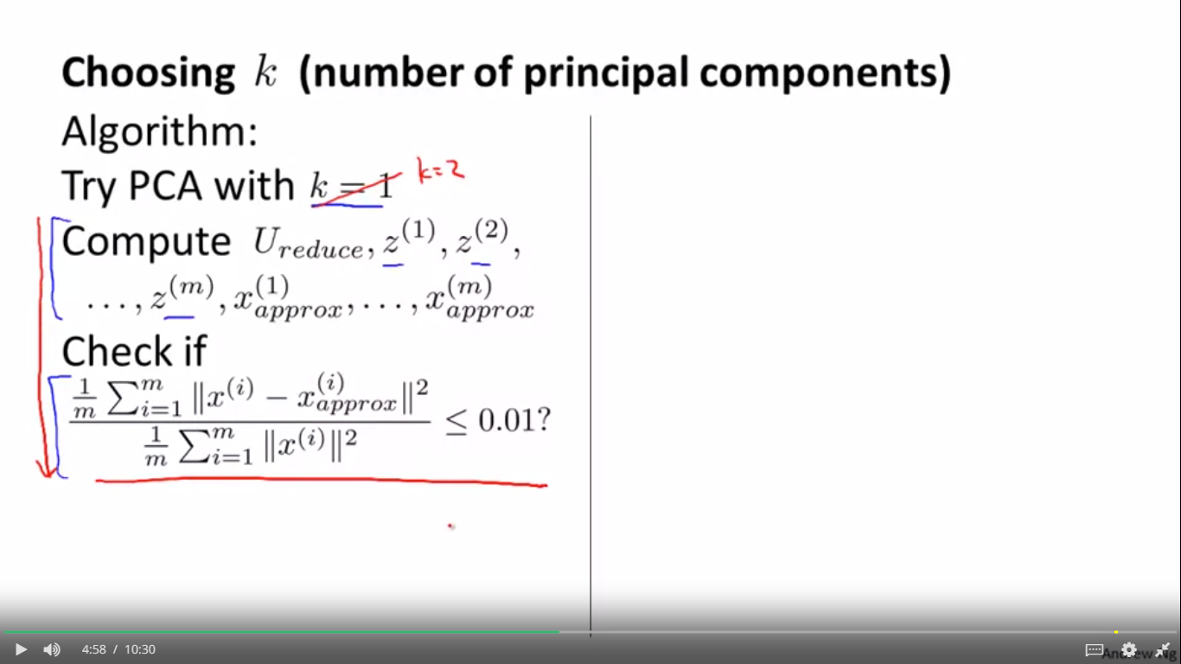

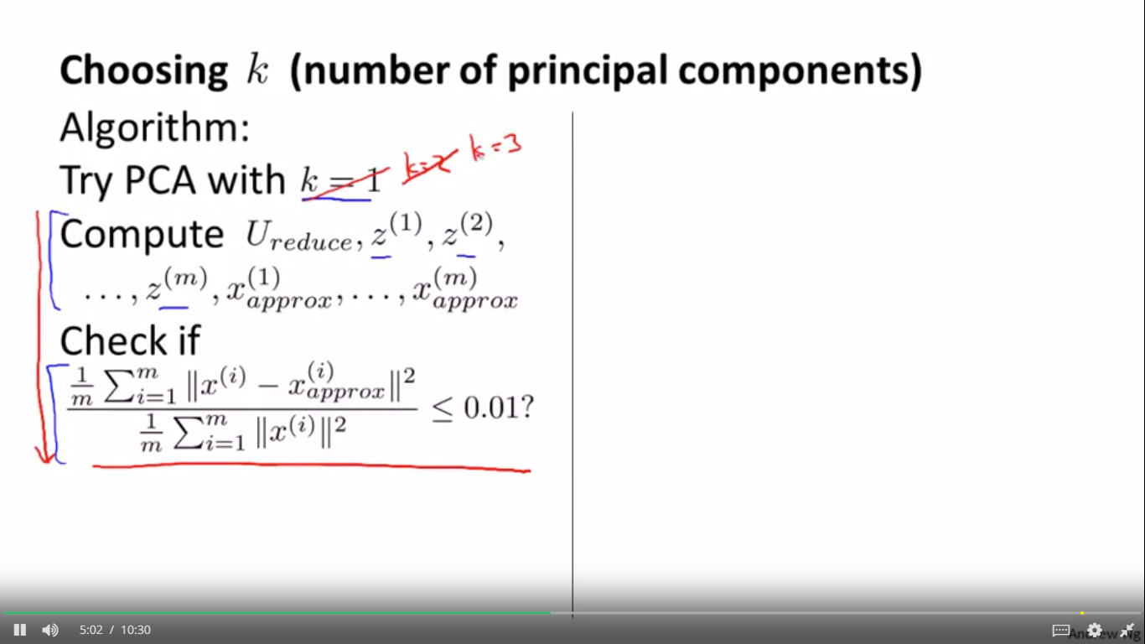

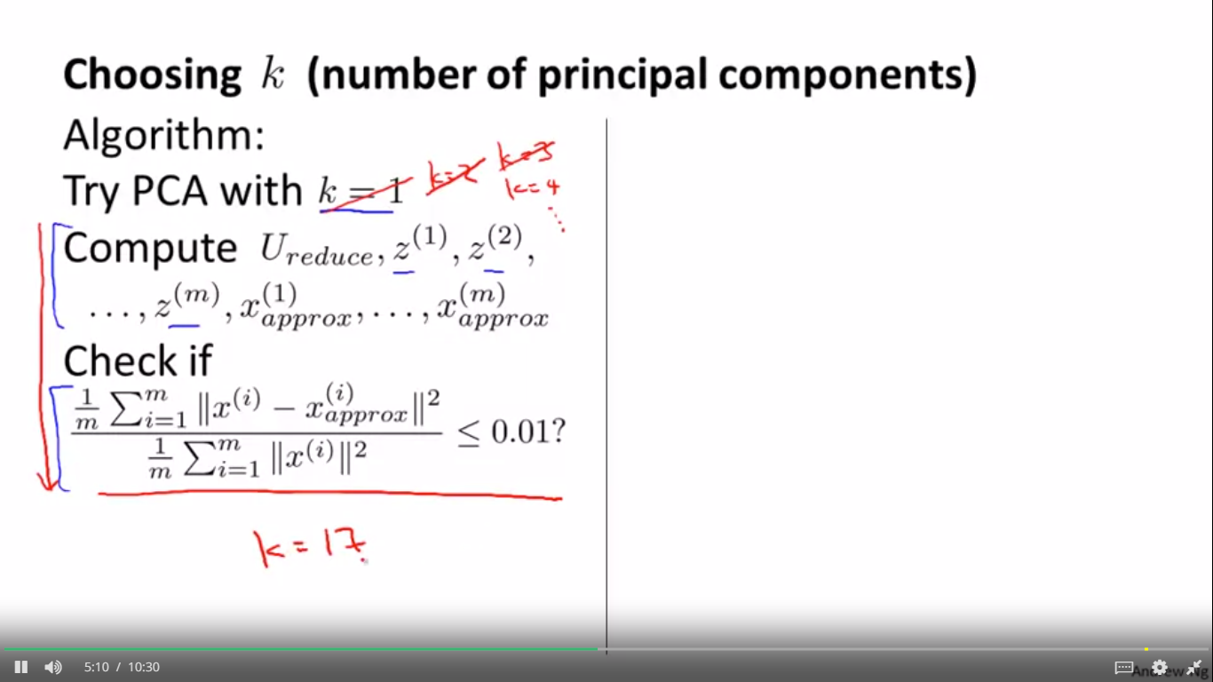

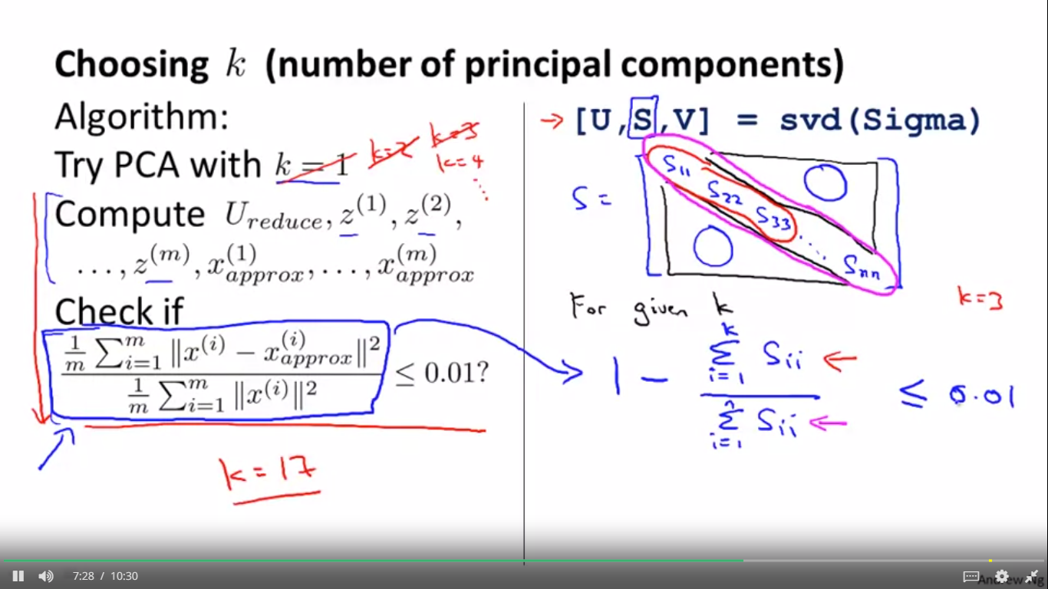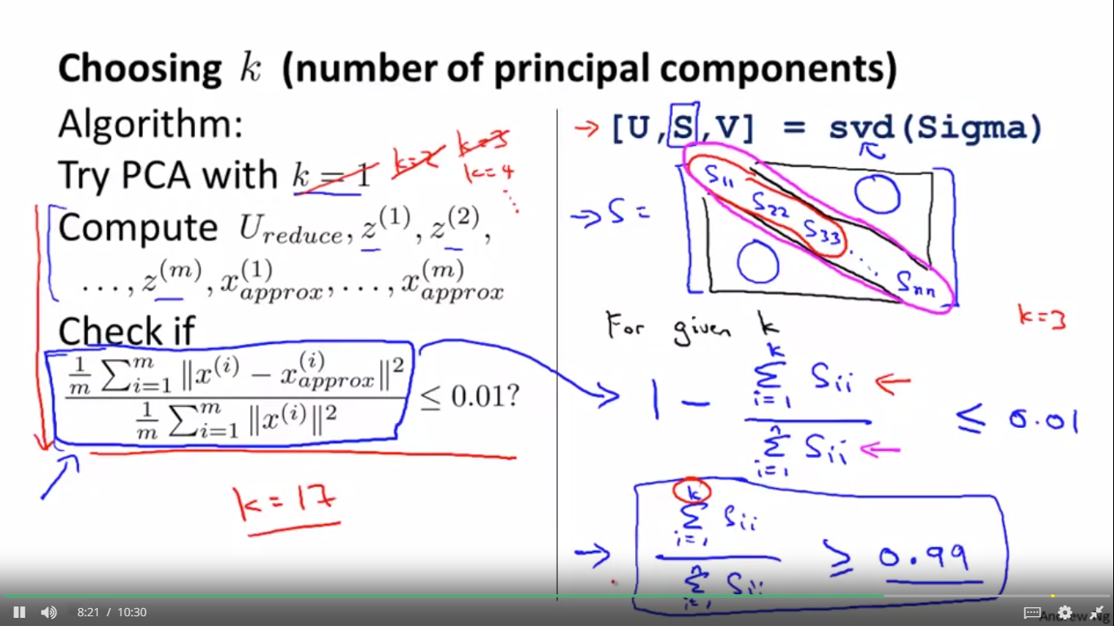

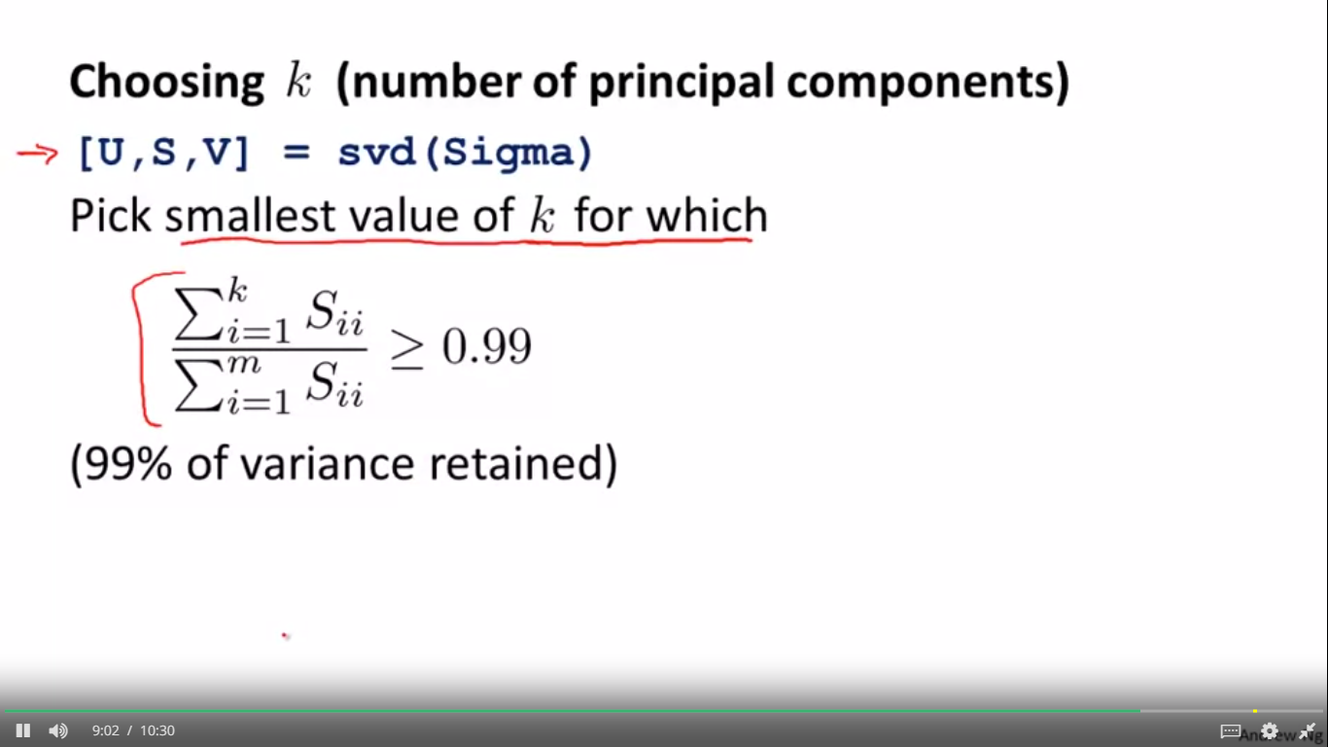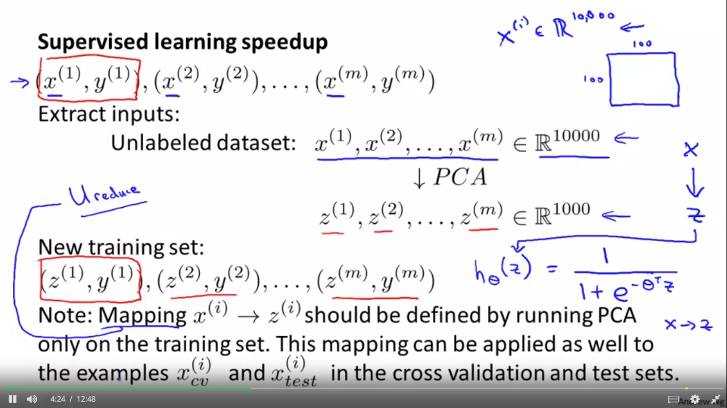

Just to summarize, when you're

running PCA, run your

PCA only on the

training set portion of the

data not the cross-validation set or the test set portion of your data.

And that defines the mapping from

x to z and you can

then apply that mapping to

your cross-validation set and your

test set and by the

way in this example I talked

about reducing the data from

ten thousand dimensional to one

thousand dimensional, this is actually

not that unrealistic. For many

problems we actually reduce the dimensional data.

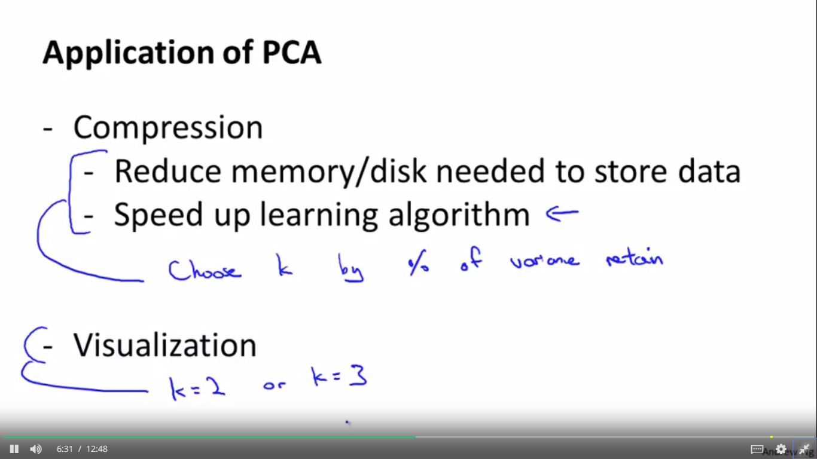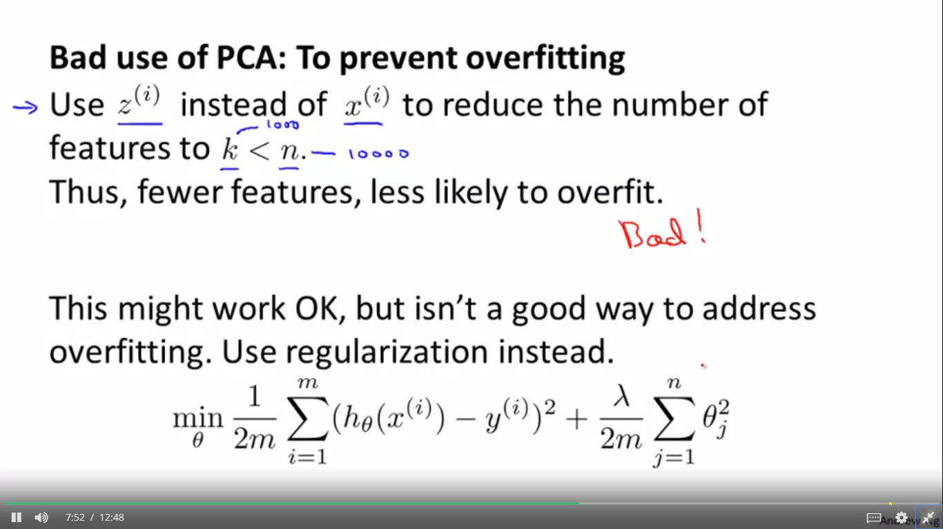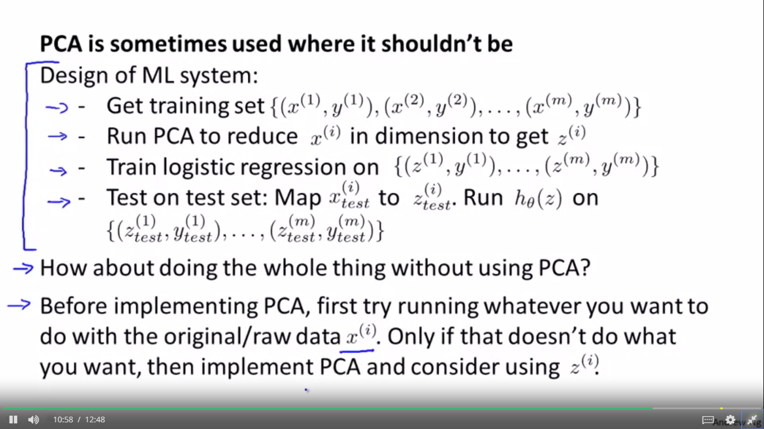

GAUSSIAN DISTRIBUTION

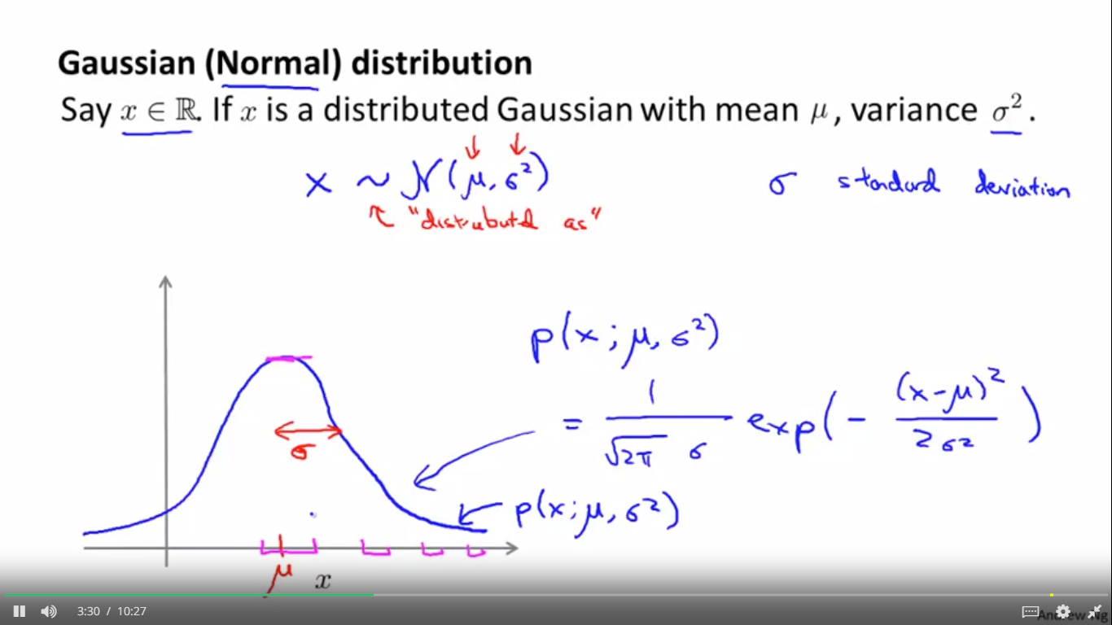

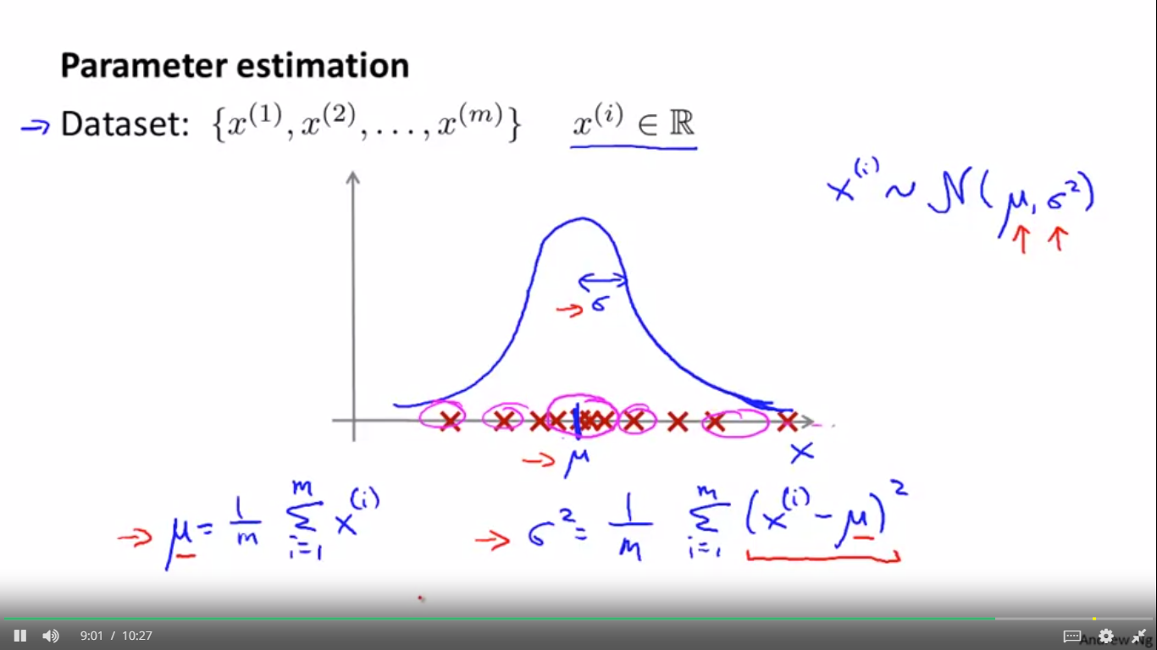

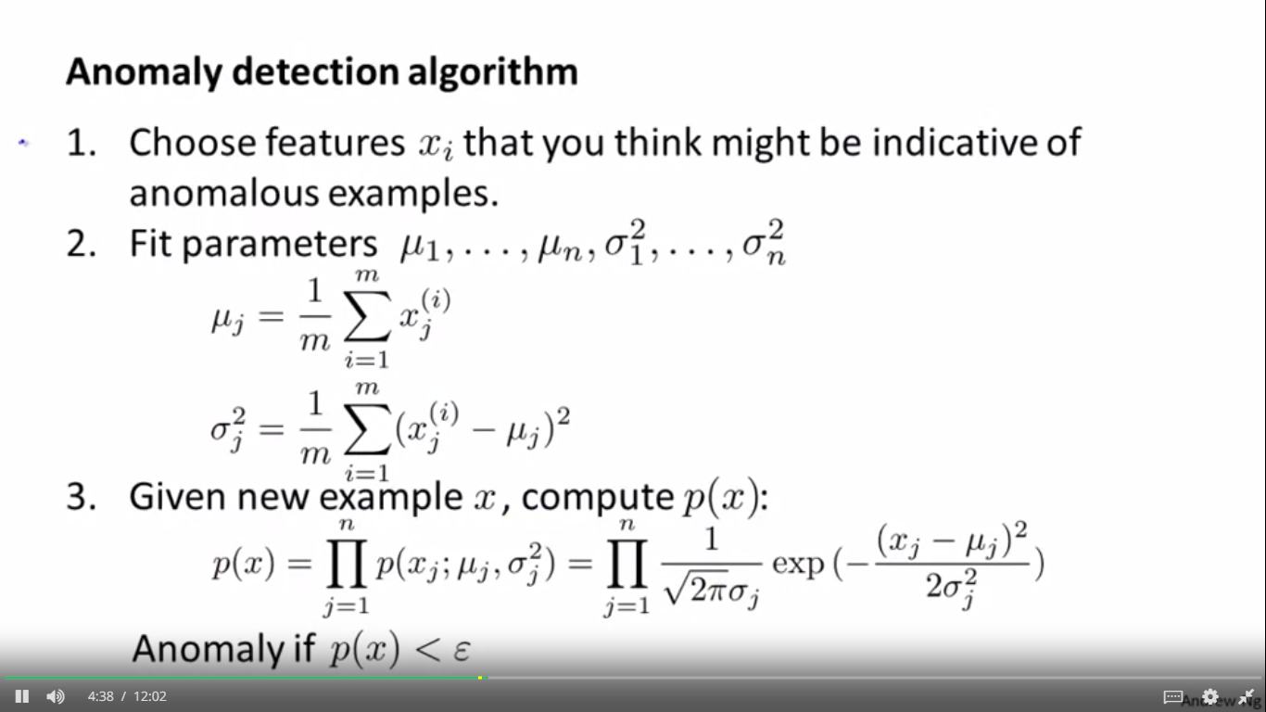 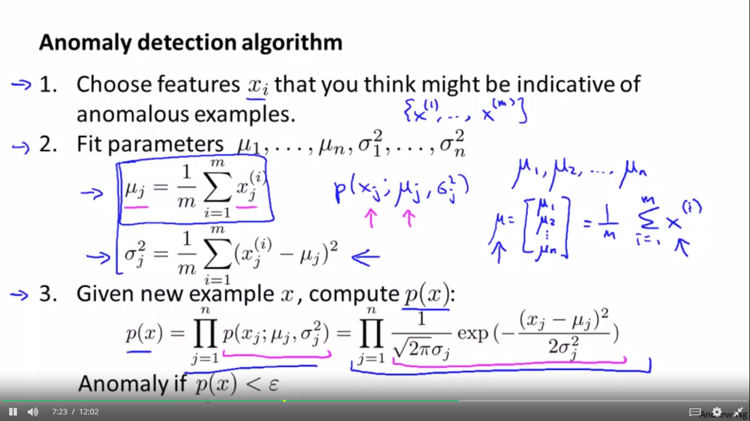

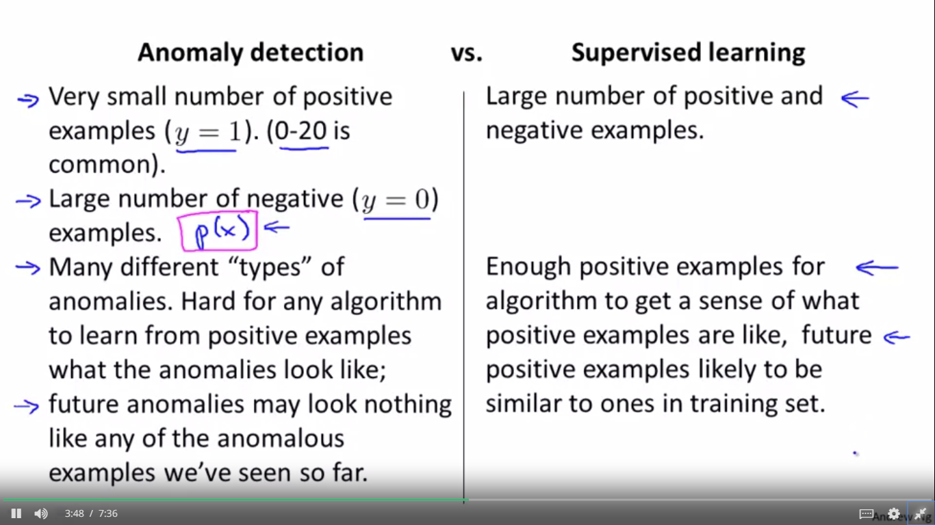 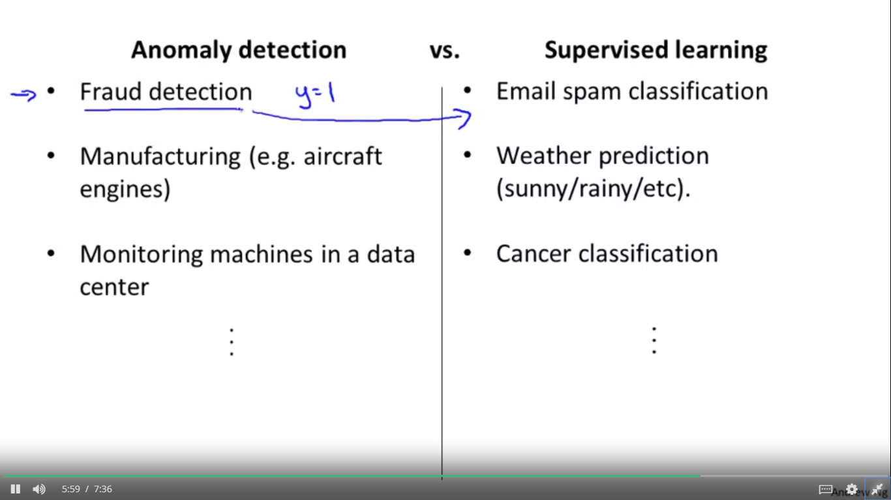

HOW TO CONVERT FEATURES INTO NORMAL DISTRIBUTION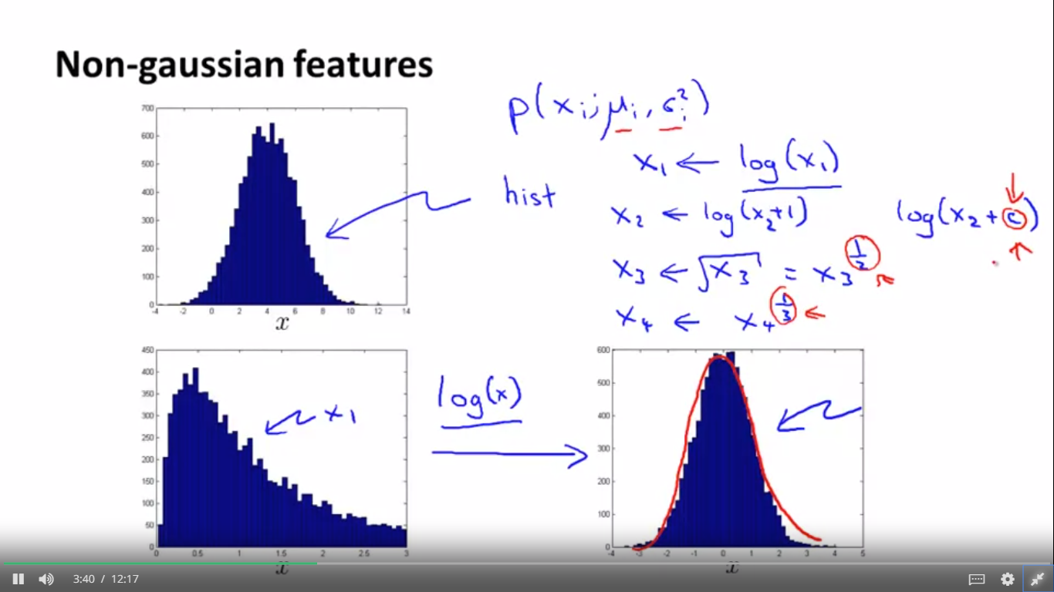

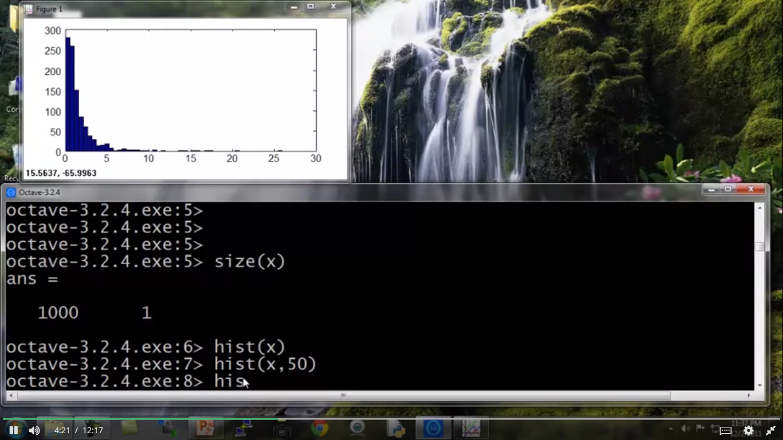

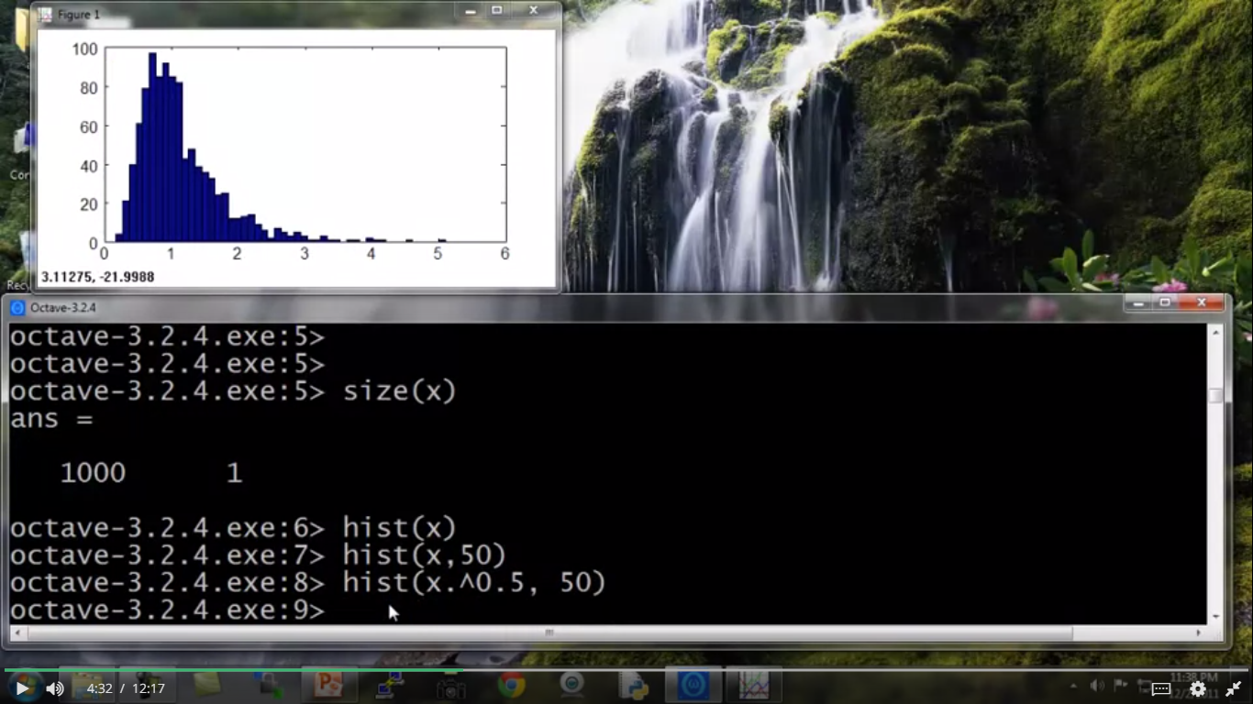

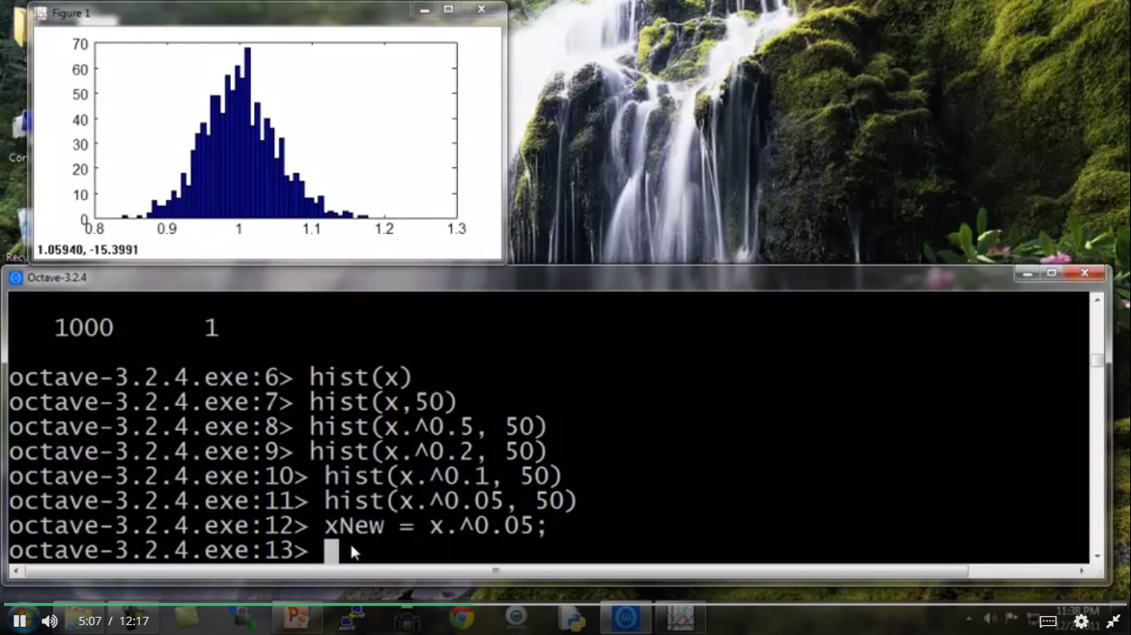

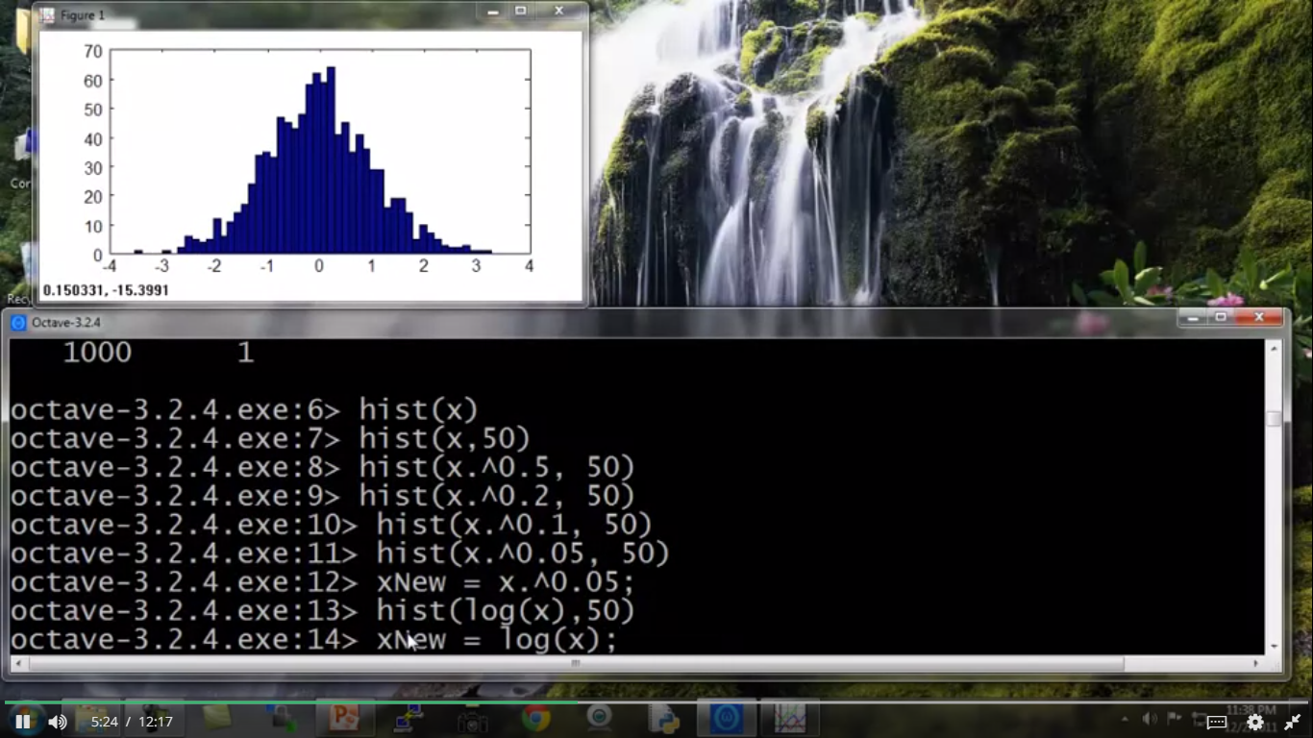

ALGORITHM FOR LARGE DATASET

For large dataset, plot J(theta) and J(cv) for a small value of m(no of dataset) and check the variance. If it is large then go for large dataset. If variance is less for small value of m then don’t go for large dataset as it is not going to help you anymore. If variance is very less that add some features in it or layers of neural network to shift to large variance and the go for large dataset.

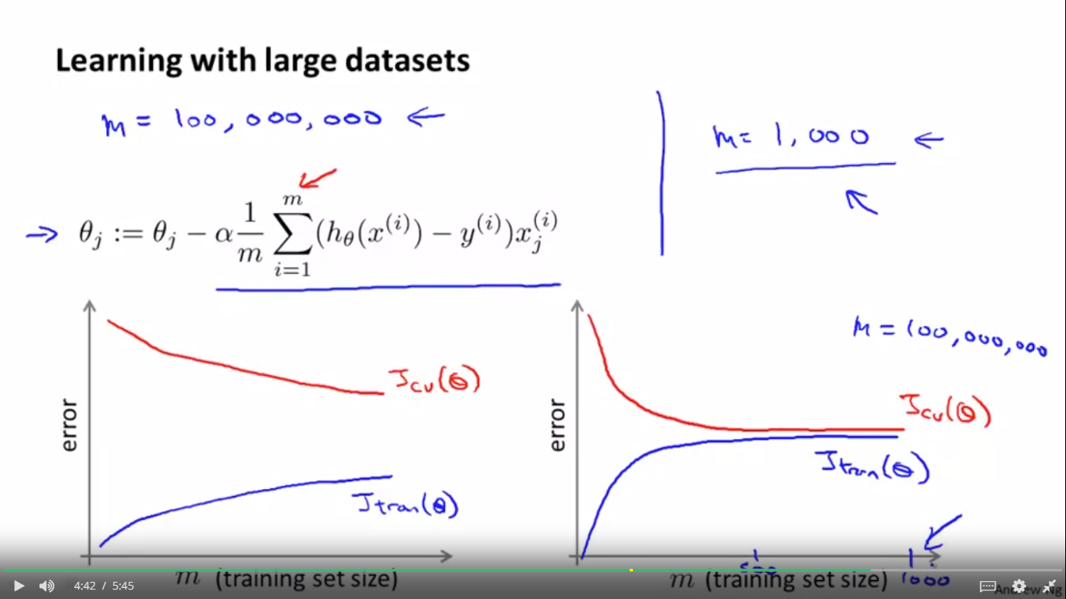

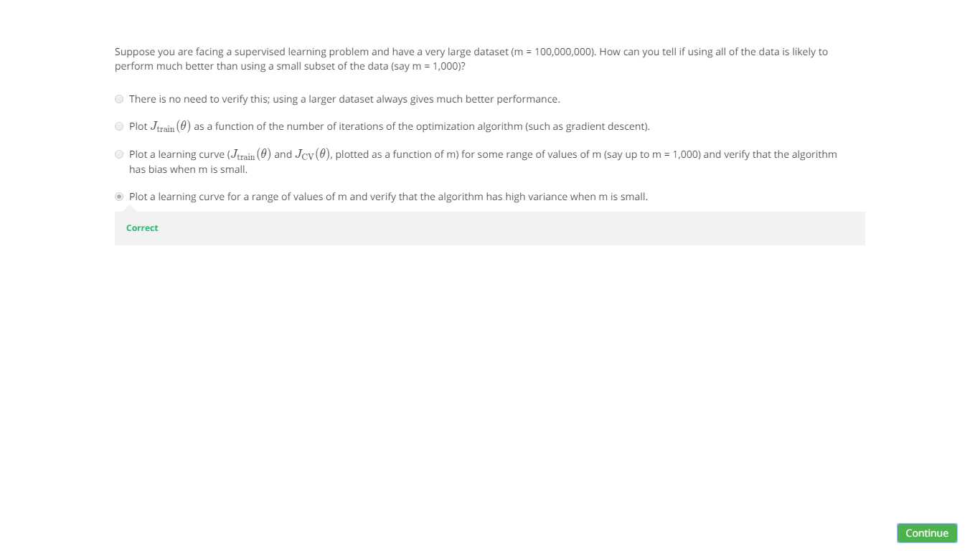

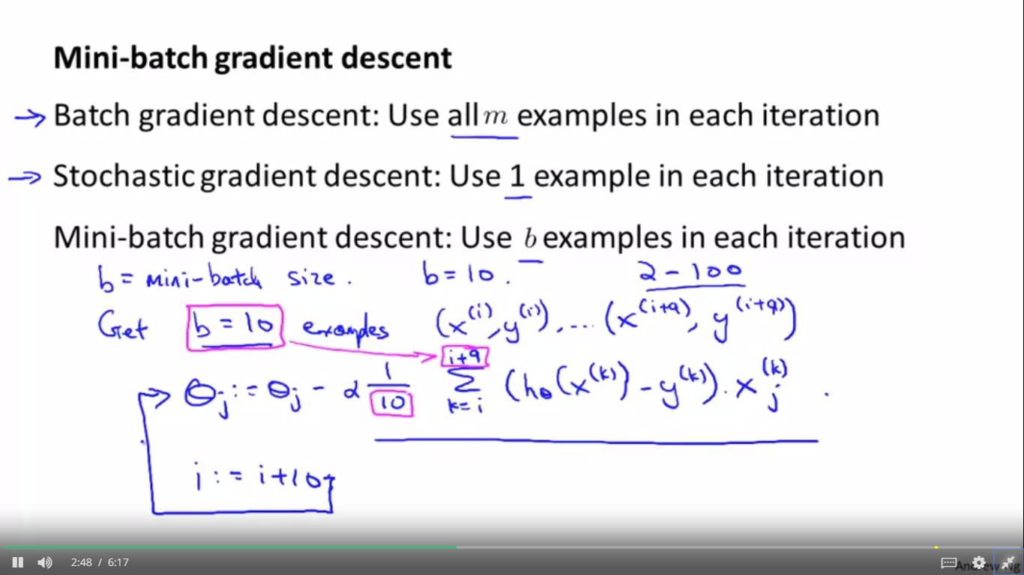

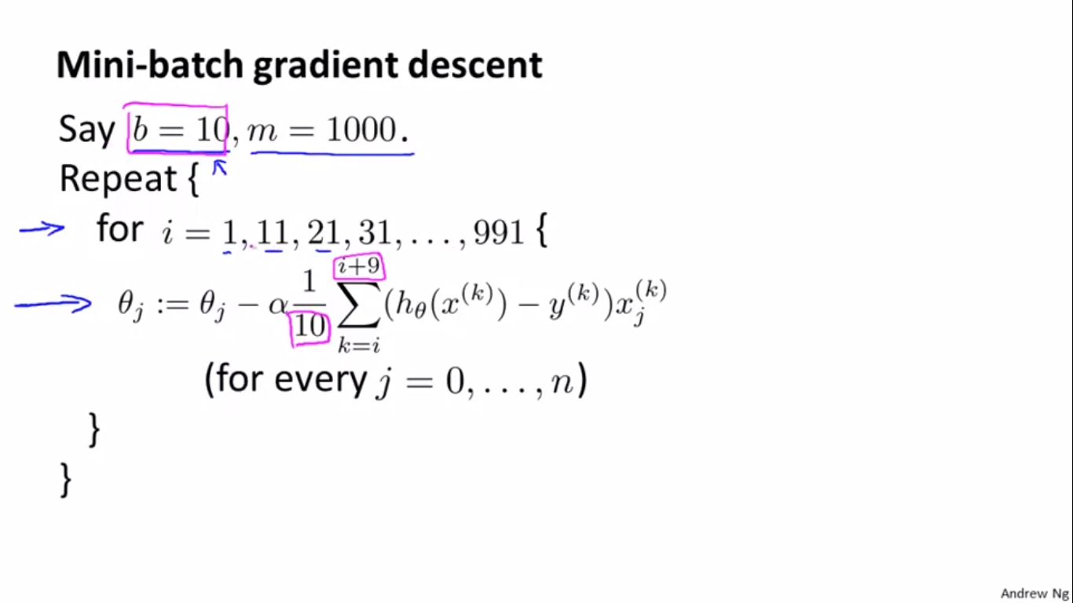

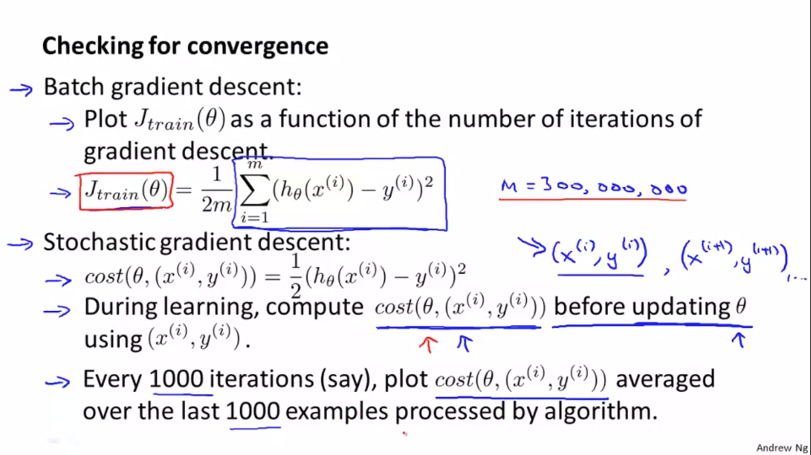

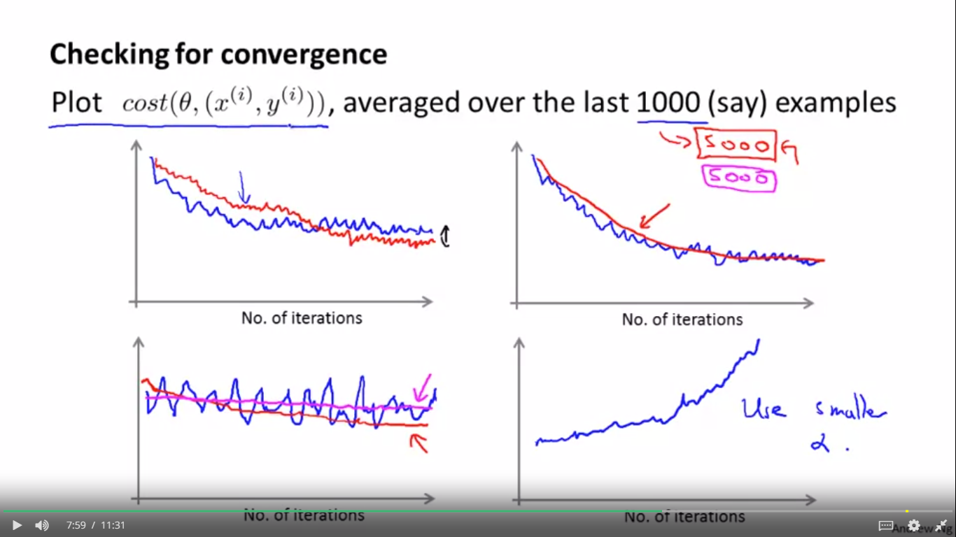

You now know about the stochastic gradient descent algorithm.

But when you're running the algorithm, how do you make sure that it's completely debugged and is converging okay?

Equally important, how do you tune the learning rate alpha with Stochastic Gradient Descent.

In this video we'll talk about some techniques for doing these things, for making sure it's converging and for picking the learning rate alpha.

Back when we were using batch gradient descent, our standard way for making sure that

gradient descent was converging was we would plot the optimization cost function as a function of the number of iterations.

So that was the cost function and we would make sure that this cost function is decreasing on every iteration.

When the training set sizes were small, we could do that because we could compute the sum pretty efficiently.

But when you have a massive training set size then you don't want to have to pause your algorithm periodically.

You don't want to have to pause stochastic gradient descent periodically in order to compute this cost function

since it requires a sum of your entire training set size.

And the whole point of stochastic gradient was that you wanted to start to make progress

after looking at just a single example without needing to occasionally scan through your entire training set

right in the middle of the algorithm, just to compute things like the cost function of the entire training set.

So for stochastic gradient descent, in order to check the algorithm is converging, here's what we can do instead.

Let's take the definition of the cost that we had previously.

So the cost of the parameters theta with respect to a single training example is just one half of the square error on that training example.

Then, while stochastic gradient descent is learning, right before we train on a specific example.

So, in stochastic gradient descent we're going to look at the examples xi, yi, in order, and

then sort of take a little update with respect to this example.

And we go on to the next example, xi plus 1, yi plus 1, and so on, right?

That's what stochastic gradient descent does.

So, while the algorithm is looking at the example xi, yi, but before it has updated the parameters theta

using that an example, let's compute the cost of that example.

Just to say the same thing again, but using slightly different words.

A stochastic gradient descent is scanning through our training set right before we have updated theta using a specific training example x(i) comma y(i)

let's compute how well our hypothesis is doing on that training example.

And we want to do this before updating theta because if we've just updated theta using example,

you know, that it might be doing better on that example than what would be representative.

Finally, in order to check for the convergence of stochastic gradient descent, what we can do is every, say, every thousand iterations,

we can plot these costs that we've been computing in the previous step.

We can plot those costs average over, say, the last thousand examples processed by the algorithm.

And if you do this, it kind of gives you a running estimate of how well the algorithm is doing.

on, you know, the last 1000 training examples that your algorithm has seen.

So, in contrast to computing J<u>train periodically which needed to scan through the entire training set.</u>

With this other procedure, well, as part of stochastic gradient descent,

it doesn't cost much to compute these costs as well right before updating to parameter theta.

And all we're doing is every thousand integrations or so, we just average the last 1,000 costs that we computed and plot that.

And by looking at those plots, this will allow us to check if stochastic gradient descent is converging.

So here are a few examples of what these plots might look like.

Suppose you have plotted the cost average over the last thousand examples,

because these are averaged over just a thousand examples, they are going to be a little bit noisy and so,

it may not decrease on every single iteration.

Then if you get a figure that looks like this, So the plot is noisy

because it's average over, you know, just a small subset, say a thousand training examples.

If you get a figure that looks like this, you know that would be a pretty decent run with the algorithm,

maybe, where it looks like the cost has gone down and then this plateau that looks kind of flattened out, you know, starting from around that point.

look like, this is what your cost looks like then maybe your learning algorithm has converged.

If you want to try using a smaller learning rate, something you might see is that

the algorithm may initially learn more slowly so the cost goes down more slowly.

But then eventually you have a smaller learning rate is actually possible for the algorithm to end up at a, maybe very slightly better solution.

So the red line may represent the behavior of stochastic gradient descent using a slower, using a smaller leaning rate.

And the reason this is the case is because, you remember, stochastic gradient descent doesn't just converge to the global minimum,

is that what it does is the parameters will oscillate a bit around the global minimum.

And so by using a smaller learning rate, you'll end up with smaller oscillations.

And sometimes this little difference will be negligible

and sometimes with a smaller than you can get a slightly better value for the parameters.

Here are some other things that might happen.

Let's say you run stochastic gradient descent and you average over a thousand examples when plotting these costs.

So, you know, here might be the result of another one of these plots.

Then again, it kind of looks like it's converged.

If you were to take this number, a thousand, and increase to averaging over 5 thousand examples.

Then it's possible that you might get a smoother curve that looks more like this.

And by averaging over, say 5,000 examples instead of 1,000, you might be able to get a smoother curve like this.

And so that's the effect of increasing the number of examples you average over.

The disadvantage of making this too big of course is that now you get one date point only every 5,000 examples.

And so the feedback you get on how well your learning learning algorithm is doing is, sort of, maybe it's more delayed

because you get one data point on your plot only every 5,000 examples rather than every 1,000 examples.

Along a similar vein some times you may run a gradient descent and end up with a plot that looks like this.

And with a plot that looks like this, you know, it looks like the cost just is not decreasing at all.

It looks like the algorithm is just not learning.

It's just, looks like this here a flat curve and the cost is just not decreasing.

But again if you were to increase this to averaging over a larger number of examples

it is possible that you see something like this red line

it looks like the cost actually is decreasing, it's just that the blue line averaging over 2, 3 examples,

the blue line was too noisy so you couldn't see the actual trend in the cost actually decreasing

and possibly averaging over 5,000 examples instead of 1,000 may help.

Of course we averaged over a larger number examples that we've averaged here over 5,000 examples,

I'm just using a different color, it is also possible that you that see a learning curve ends up looking like this.

That it's still flat even when you average over a larger number of examples.

And as you get that, then that's maybe just a more firm verification that

unfortunately the algorithm just isn't learning much for whatever reason.

And you need to either change the learning rate or change the features or change something else about the algorithm.

Finally, one last thing that you might see would be if you were to plot these curves

and you see a curve that looks like this, where it actually looks like it's increasing.

And if that's the case then this is a sign that the algorithm is diverging.

And what you really should do is use a smaller value of the learning rate alpha.

So hopefully this gives you a sense of the range of phenomena you might see

when you plot these cost average over some range of examples as well as

suggests the sorts of things you might try to do in response to seeing different plots.

So if the plots looks too noisy, or if it wiggles up and down too much, then try increasing the number of examples

you're averaging over so you can see the overall trend in the plot better.

And if you see that the errors are actually increasing, the costs are actually increasing, try using a smaller value of alpha.

Finally, it's worth examining the issue of the learning rate just a little bit more.

We saw that when we run stochastic gradient descent, the algorithm will start here and sort of meander towards the minimum

And then it won't really converge, and instead it'll wander around the minimum forever.

And so you end up with a parameter value that is hopefully close to the global minimum that won't be exact at the global minimum.

In most typical implementations of stochastic gradient descent, the learning rate alpha is typically held constant.

And so what you we end up is exactly a picture like this.

If you want stochastic gradient descent to actually converge to the global minimum,

there's one thing which you can do which is you can slowly decrease the learning rate alpha over time.

So, a pretty typical way of doing that would be to set alpha equals some constant 1 divided by iteration number plus constant 2.

So, iteration number is the number of iterations you've run of stochastic gradient descent,

so it's really the number of training examples you've seen

And const 1 and const 2 are additional parameters of the algorithm

that you might have to play with a bit in order to get good performance.

One of the reasons people tend not to do this is because you end up needing to spend time

playing with these 2 extra parameters, constant 1 and constant 2, and so this makes the algorithm more finicky.

You know, it's just more parameters able to fiddle with in order to make the algorithm work well.

But if you manage to tune the parameters well, then the picture you can get is that

the algorithm will actually around towards the minimum, but as it gets closer

because you're decreasing the learning rate the meanderings will get smaller and smaller

until it pretty much just to the global minimum. I hope this makes sense, right?

And the reason this formula makes sense is because as the algorithm runs, the iteration number becomes large So alpha will slowly become small,

and so you take smaller and smaller steps until it hopefully converges to the global minimum.

So If you do slowly decrease alpha to zero you can end up with a slightly better hypothesis.

But because of the extra work needed to fiddle with the constants and because frankly usually we're pretty happy

with any parameter value that is, you know, pretty close to the global minimum.

Typically this process of decreasing alpha slowly is usually not done and keeping the learning rate alpha constant

is the more common application of stochastic gradient descent although you will see people use either version.

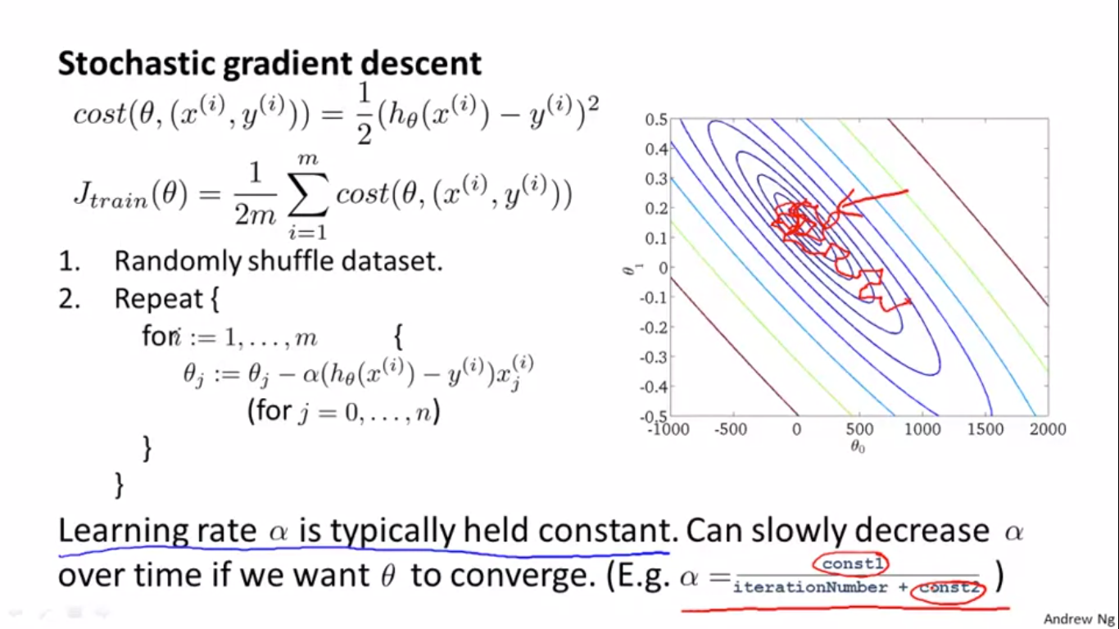

ONLINE LEARNING

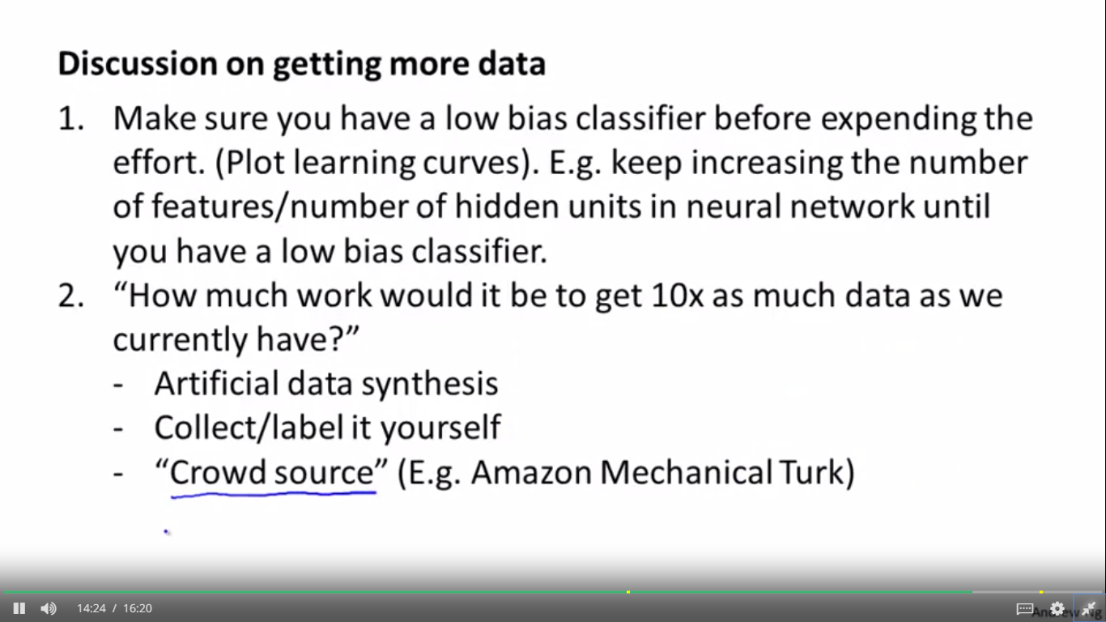

When I face a new machine

learning application very often I

will sit down with a team

and ask exactly this question,

I've asked this question over and

over and over and I've

been very surprised how often

this answer has been that.

You know, it's really not that hard,

maybe a few days of work

at most, to get ten times

as much data as we currently

have for a machine

running application and very

often if you can get

ten times as much data there

will be a way to make your algorithm do much better.

So, you know, if you

ever join the product team

11:17

working on some machine learning

application product this is

a very good questions ask yourself

ask the team don't be

too surprised if after a

few minutes of brainstorming if your

team comes up with a

way to get literally ten

times this much data, in

which case, I think you would

be a hero to that team,

because with 10 times as

much data, I think you'll really

get much better performance, just from learning from so much data.

11:39

So there are several waysand

11:47

that comprised both the ideas

of generating data from

scratch using random fonts and so on.

As well as the second idea

of taking an existing example and

and introducing distortions that amplify

to enlarge the training set A

couple of other examples of

ways to get a lot more

data are to collect the

data or to label them yourself.

12:07

So one useful calculation that

I often do is, you know,

how many minutes, how many

hours does it take to

get a certain number of

examples, so actually sit down and

figure out, you know, suppose it

takes me ten seconds to

label one example then

and, suppose that, for

our application, currently we

have 1000 labeled examples examples

so ten times as

much of that would be

if n were equal to ten thousand.

12:37

A second way to

get a lot of data is

to just collect the data and you label it yourself.

So what I mean by this is

I will often set down and

do a calculation to figure

out how much time, you

know just like how many hours

12:52

will it take, how many

hours or how many days will

it take for me or

for someone else to just sit

down and collect ten times

as much data, as we have

currently, by collecting the data ourselves and labeling them ourselves.

13:05

So, for example, that, for

our machine learning application, currently

we have 1,000 examples, so M 1,000.

13:12

That what we do is sit

down and ask, how long does

it take me really to collect and label one example.

And sometimes maybe it will

take you, you know ten

seconds to label

13:23

one new example, and so

if I want 10 X as many examples, I'd do a calculation.

If it takes me 10 seconds to get one training example.

If I wanted to get 10

times as much data, then I need 10,000 examples.

So I do the calculation, how long

is it gonna take to label,

to manually label 10,000 examples,

if it takes me 10 seconds to label 1 example.

13:47

So when you do this calculation,

often I've seen many you

would be surprised, you know,

how little, or sometimes a

few days at work, sometimes a

small number of days of work,

well I've seen many teams be very

surprised that sometimes how

little work it could be,

to just get a lot more

data, and let that be

a way to give your learning

app to give you a huge boost

in performance, and necessarily, you

know, sometimes when you've just

managed to do this, you

will be a hero and whatever product

development, whatever team you're working

on, because this can

be a great way to get much better performance.

14:17

Third and finally, one sometimes

good way to get a

lot of data is to use

what's now called crowd sourcing.

So today, there are a

few websites or a few

services that allow you

to hire people on

the web to, you know, fairly

inexpensively label large training sets for you.

So this idea of crowd

sourcing, or crowd sourced

data labeling, is something

that has, is obviously, like

an entire academic literature,

has some of it's own complications and

so on, pertaining to labeler reliability.

14:50

Maybe, you know, hundreds of thousands

of labelers, around the

world, working fairly inexpensively to

help label data for you,

and that I've just had mentioned,

there's this one alternative as well.

And probably Amazon Mechanical Turk

systems is probably the most

popular crowd sourcing option right now.

15:06

This is often quite a

bit of work to

get to work, if you want

to get very high quality labels,

but is sometimes an

option worth considering as well.

15:17

If you want to try to

hire many people, fairly inexpensively

on the web, our labels launch miles of data for you.

15:26

So this video, we

talked about the idea of

artificial data synthesis of

either creating new data

from scratch, looking, using

the ramming funds as an example,

or by amplifying an

existing training set, by taking

existing label examples and

introducing distortions to it,

to sort of create extra label examples.

15:46

And finally, one thing that

I hope you remember from this

video this idea of if

you are facing a machine learning

problem, it is often worth doing two things.

One just a sanity check,

with learning curves, that having more data would help.

And second, assuming that that's the case,

I will often seat down and

ask yourself seriously: what would

it take to get ten times as

much creative data as you

currently have, and not always,

but sometimes, you may be

surprised by how easy that

turns out to be, maybe

a few days, a few weeks at

work, and that can be

a great way to give your learning algorithm a huge boost in performance